Climate-Resilient Asset Management Worksheet

This exercise is a simplified version of the climate risk assessment process detailed in Chapter 6 of Managing Infrastructure Assets for Sustainable Development. In order to complete the 11 steps, instructions will direct you towards figures from the chapter that provide additional information you will find useful. The intention of this worksheet is to aid you in understanding the connection between climate change projections and service/asset risks and applying response strategies that fit within your broader asset management objectives.
Step 1
1.
2.
3.
4.
Go to https://climateknowledgeportal.worldbank.org/
Select “Country”, then find your nation on the world map. Click on the “Climate Data” header, choose “Projections”
Choose a climate projection facing your nation. You can use the Data Snapshot, or
choose a climate indicator under “Variable”
5. Note it here
Alternative: Use climate projections released by your federal government for your region

Climate Hazard | Service Areas | Assets

Step 2

Identify the climate hazard from the projection. List 3 service areas from your local government that could be impacted, and key assets those service areas rely on. See Figure 3, page 210 for climate change hazards

Step 3
Draft a climate impact statement connecting the climate hazard to an asset/service area that could be impacted, and a resulting consequence. See page 218 for Climate Impact Statements, and Appendix A, page 249 for climate hazard impacts.

causing resulting in
(Climate Hazard) (Asset/Service Impact)

_
(Consequence)

Step 4
Assess the adaptive capacity and exposure to determine the vulnerability of the identified asset/service area to the climate hazard. Place an X in most applicable boxes. See Figure 9, page 223
Exposure: If the climate impact were to occur, will it affect service delivery?
1  No impact | 2  Sporadic or small decline | 3  Noticeable decline | 4  Large decline | 5  Severely compromised

Adaptive Capacity: Can the service area respond to the climate impact with minimal cost, additional resources and disruption?
1 | 2 | 3 | 4 | 5
$$$$$, new skills and interventions | $$$$, new skills and interventions | $$$, staff interventions, possible new skills | $$, existing staff skillset | $, little staff intervention

Step 5
Assess the likelihood and consequence of the climate impact statement to determine its risk to the community. Check the most applicable boxes and place the resulting score on the Risk Matrix. See figures 11-12, pages 226-228
Consequence: How severe will the effects of the climate impact statement be if they occur?
 | Public Safety | Environmental  Harm | Service  Interruption | Financial  Impact | Asset Damage
Very Low (1)
Low (2)
Moderate (3)
High (4)
Very High (5)

1  Very Low | 2  Low | 3  Moderate | 4  High | 5  Very High

Likelihood: How likely is it that the climate impact will occur?

Step 9
Cost and effectiveness are typically the most important influencing dynamics of whether a response strategy is accepted. Evaluate your response strategy by placing an X where you believe your response would land on the cost- benefit matrix.
Cost
Benefit

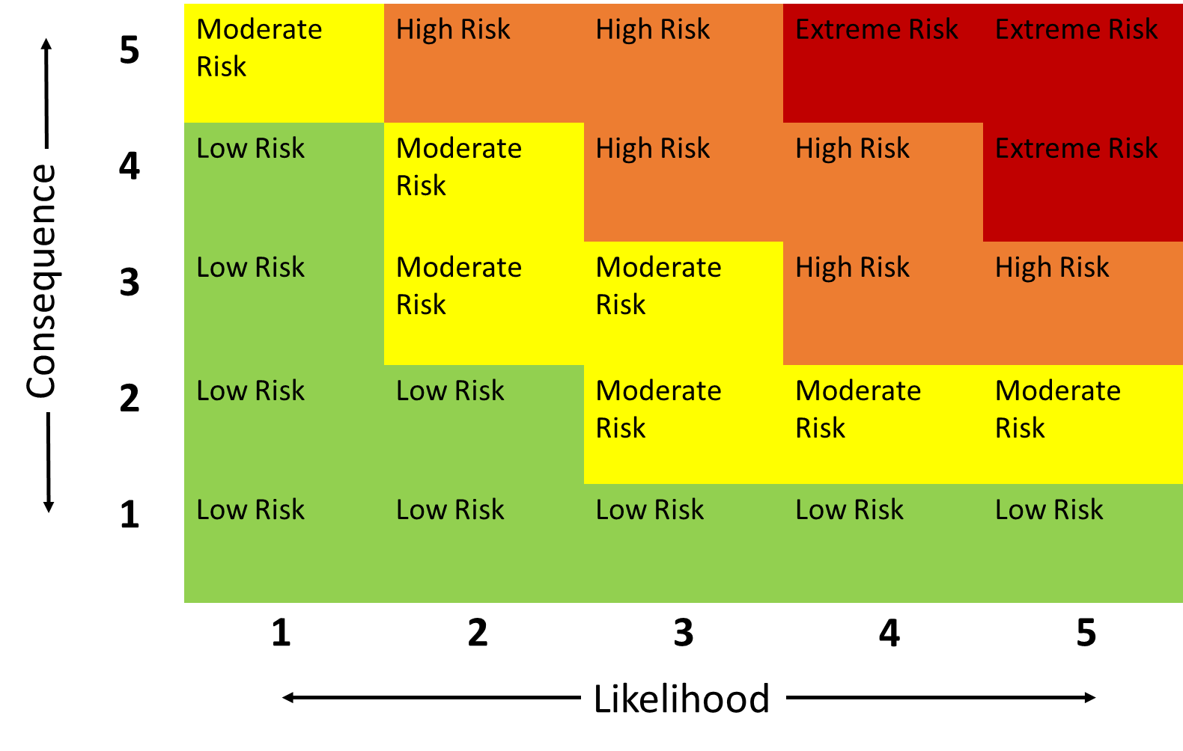Step 8
Step 6
Multiple the average consequence score from across the five categories by the likelihood:
x =
Step 7
Time for a Strategic Evaluation. Does this Climate Impact Statement’s place on the Risk Matrix make sense, given your knowledge of past hazard occurrences in your community? See Strategic Evaluation, page 231.
Yes No
Why?
Answer:
Devise a response strategy. What policies, operations and maintenance changes, retrofits or new infrastructure could be used to reduce the risk posed by the climate impact statement? See Responding to Climate Risks, page 234
Answer:

Step 10
Check through the other influencing dynamics that can determine the appropriateness of a response strategy. Which do your response strategy align with? Check each that applies. See pages 240-241.

Balanced with other community objectives? |  | Objective?
Yes No |  | Maintain current risk
 |  | Reduce risk level
 |  | Limit risk increase
Timeline? Near-term Long-term |  | Feasible? | Yes No
Multiple protections? | Yes No | Low regret? | Yes No
New Assets? | Yes No | Acceptable? Yes No
Sufficient information? Yes No |  | Flexible? | Yes No
Co-Benefits:

Step 11
Action your response strategy by summarizing this worksheet for integration within your Asset Management Action Plan. See Exercise 10, page 245

Action
Rationale
Timeframe
Ownership
Resources
Funding

__________________________________
(Your Name)

