**Africa’s External Debt as a**

**Structural Impediment to Development and Climate Action**

Dr. Fadhel Kaboub

[kaboubf@denison.edu](mailto:kaboubf@denison.edu)

Senior Advisor at *Power Shift Africa*

Member of *The* *Independent Expert Group on Just Transition and Development*

*Associate Professor of Economics at Denison University (on leave)*

**Context**

Africa’s sovereign debt distress is jeopardizing our collective efforts to meet the climate challenge and the SDGs by 2030. This external debt crisis is further reducing the fiscal policy space necessary to tackle national priorities such as health, education, infrastructure, and other public services in the Global South. Unfortunately, the existing financial architecture and a high interest rate environment are forcing African countries to accept punitive loan conditionalities that weaken the state, hurt the most vulnerable people, and lock countries into further dependence on external financing. **In 2024, African countries are expected to pay $163 billion in debt service**. That is to say, Africa is paying more in debt service in one single year than all the climate finance pledges *combined,* includingthe $100 billion from Copenhagen, the Green Climate Fund, and the Loss and Damage Fund! More than half of African countries spend more on debt service than on healthcare and/or education.

**The structural root causes of Africa’s external debt**

While Africa’s external debt remains a serious problem that requires the utmost attention, cooperation, coordination, and solidarity, it is important to recognize that external debt cycles are symptoms of much deeper structural deficiencies[1] that have been imposed on African countries via the existing global economic architecture which encompasses the rules of finance, trade, investment, and taxation, all of which have been established and enforced in a particular historical and geopolitical context that serves the interest of the Global North.

The rules of the global economic architecture have imposed on Africa an economic role that is systematically conducive to unsustainable debt burdens and condemns the continent to endless economic entrapment. Today, Africa plays the role of the place where: 1) the industrialized world acquires cheap raw materials (including critical minerals); 2) industrial output from the Global North can be dumped in our large consumer market; and 3) obsolete technologies, and low-tech, low labor-cost, assembly-line manufacturing that is no longer needed in the Global North is outsourced to in the name of “development”, “cooperation”, and “job creation”, which in fact guarantees that ***Africa remains locked at the bottom of the global value chain***.

There are three fundamental economic deficiencies that create and perpetuate Africa’s external debt: food deficits, energy deficits, and manufacturing value-added deficits (See Figures 1 and 2 below).

**Figure 1: Africa’s Imports**

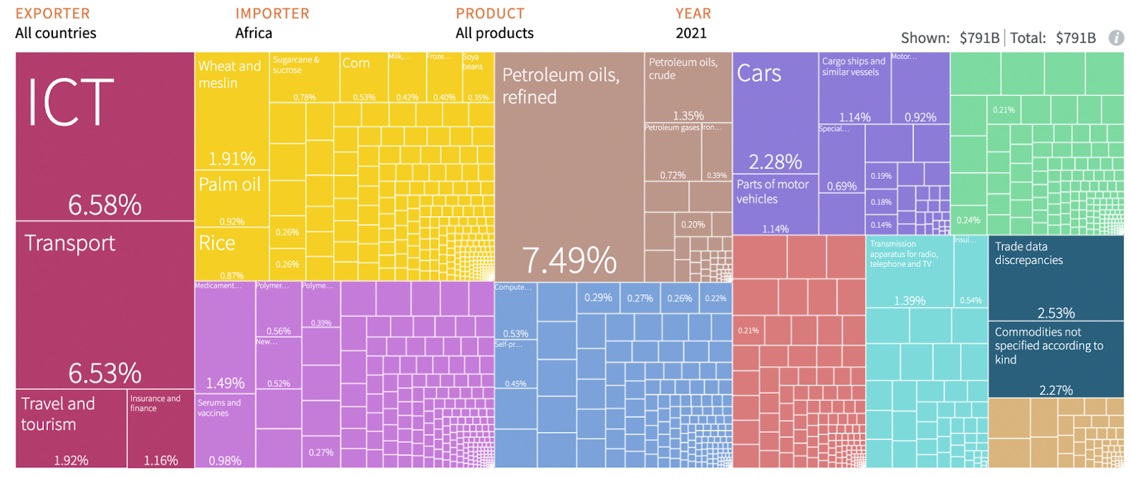

**Source**:<https://atlas.cid.harvard.edu/>

**Figure 2: Africa’s Imports**

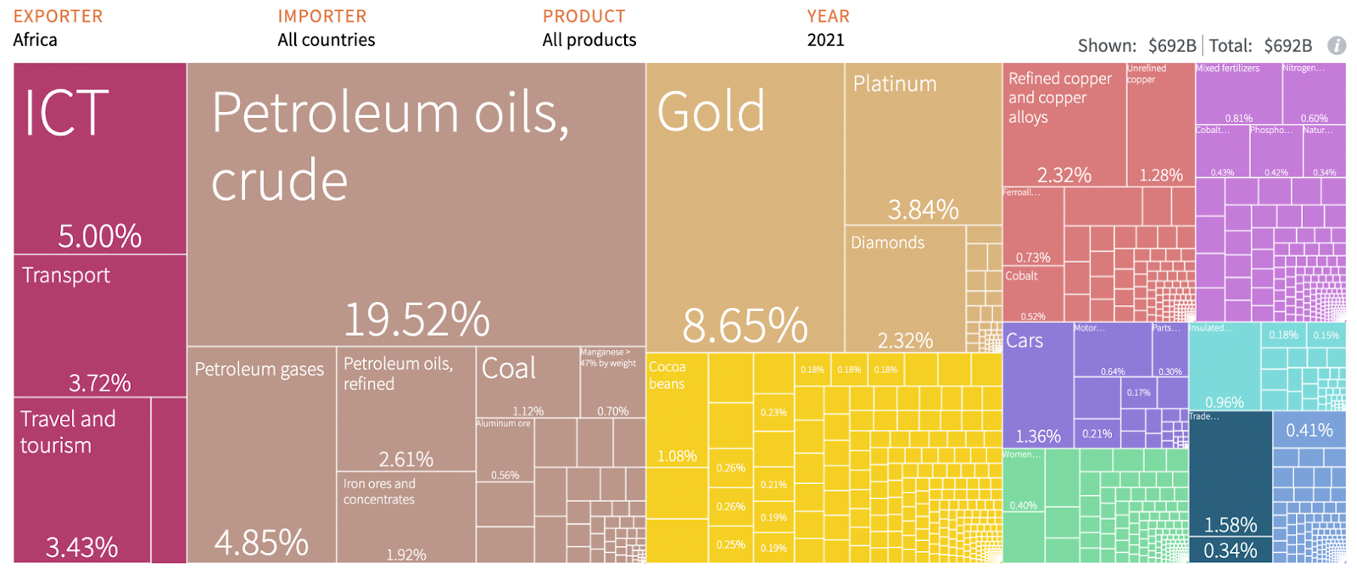

**Source**:<https://atlas.cid.harvard.edu/>

First, when we speak of energy deficits, it includes our biggest oil exporters in Africa like Nigeria and Angola who import more than 80% of their fuel from international markets. This is not by accident, it’s by design, because we have always been denied access to technology for prospection, drilling, and refining oil products. Not only are we denied technology access in the old fossil fuel energy system that we want to transition away from, but we are also denied access to renewable energy technology of the future.

Second, when it comes to food deficits, Africa today imports 85% of its food, when less than a hundred years ago we used to be the breadbasket for colonial powers. Again, this is not by accident, it’s by design. What is the design? It’s the rules of international trade, such as agricultural subsidies in the global north.

As soon as the African continent started to gain independence in the 1950s, European leaders met at the Treaty of Rome meeting and essentially acknowledged that Europe had a food security problem: it was too dependent on the colonies that were becoming independent. So Europe needed to introduce its own food sovereignty program, which came into effect in 1962 when the Common Agricultural Policy (CAP) was launched. CAP remains a foundational block of the European Union to this day.

It was not just Europe of course, it was also the US, Canada, Australia, and the former Soviet Union – which is why Russia and Ukraine still dominate the grain industry. The way these countries protected their agricultural industries forced the global south, Africa in particular, to give up producing wheat, corn, barley and the core crops we need for our actual food security. Instead, we were forced to play a new role in the global economy, and the global food system, producing cash crops and supplementary agricultural products for export.

Once you start producing cash crops you have to produce for the taste of your consumers in the global north, so you start using non-native seeds that are not acclimated to your environment. You have to pump them with water that you don’t always have, and you have to import fertilizers and pesticides that you don’t have. If you do that for 30 to 40 years, you just kill the fertility of your soil. You have to double down on more potent seeds, fertilizers and pesticides that you must import on unfavorable terms, and you’re stuck in a debt trap. That is why we essentially have no food security today.

And third, when it comes to the manufacturing value-added deficits, we must acknowledge that the only manufacturing we were allowed to have in the global south is the kind where you have to import everything – the machines, the fuel to power the factories, the components to assemble with low-cost labor, and even the packaging. So we ended up with a manufacturing base that exports low value-added content and imports high value-added content. That is a trap. You can double, triple, or quadruple your exports – but you’re always locked at the bottom of the global value chain. Therefore, one of the most important aspects of reforming the international financial architecture must be an intentional strategy to **rebalance the global economy** and **to** **reposition African countries away from the bottom of the global value chain**.

These three fundamental deficits – food, energy and manufacturing – add up to a structural trade deficit year after year, decade after decade. Any country with a trade deficit finds its currency becomes weaker relative to the dollar, and with the weaker exchange rate anything we need to import the next morning – food, fuel, medicine – has to be imported at a higher cost. So we literally import inflation in the most sensitive areas, which creates the risk of social unrest, putting our governments immediately into a defensive position, trying to find a band-aid solution to this imported inflation in food, fuel and medical supplies. As a result, we subsidize food and fuel – and it is unsustainable to do that for decades.

In addition, we ask our central bankers to do their best to defend the value of the exchange rate, which they promptly do by borrowing more dollars and accelerating the debt trap. Once you have debt payments due every month or quarter, you completely rewire your economy to prioritize any economic activity that will allow you to earn those dollars. That leads to more extractive, faster acceleration of the same colonial traps you are already in. These are the roots of the problem.

**Structural solutions to Africa’s external debt and climate vulnerabilities**

The good news is that all the structural solutions to Africa’s external debt problems happen to be climate adaptation solutions. The three structural problems outlined above suggest that Africa’s debt problems require strategic cooperation for investments in food sovereignty and agroecology, renewable energy sovereignty, and Pan-African high value-added industrial policies that prioritize leveraging the complementarity of resources and capabilities and the economies of scale to manufacture and deploy renewable energy, clean cooking, and green public transportation infrastructure across the continent. This is a win-win-win scenario across all the major challenges we face whether it’s debt development, climate, health, poverty, hunger, energy access and beyond.

**Financing Africa’s Climate and Development Priorities**

Africa must reject the current development and climate finance framework that simply amounts to economic entrapment. The fact that African countries are locked at the bottom of the value chain and suffer from perpetual external debt cycles after decades of following the economic prescriptions of its creditors and development “partners” means one of two things; these so-called “partners” are either incompetent or have been engaging in intentional economic entrapment. Either way their approach needs to be rejected.

Since Africa’s climate and development needs are aligned (based on the structural analysis outlined above), we need to think of finance for climate and financing for development in a single coherent and comprehensive framework. Africa is the continent that has contributed the least in terms of cumulative CO2 emissions (less than 4%), yet it bears the brunt of climate-induced damage. The Global North has exceeded its carbon budget and therefore owes a climate debt. And when someone owes debt, that debt needs to be paid sooner rather than later. As it stands, the Global North is essentially in debt default with total impunity.

In the current climate finance paradigm, the dynamics are shockingly absurd. For instance, if a nation is owed $100 in climate finance, instead of a simple $100 payment from the Global North to that nation, in practice, the country that is owed the $100 is expected to receive only $3, disbursed in 12 installments over a four-year period, with stringent conditions attached. These conditions include requirements for key performance indicators (KPIs), transparency, accountability, and quarterly reporting, under threat of disbursement suspension. Then, a $7 loan at concessional interest rates is offered, albeit with restrictive conditions on how funds can be utilized. An additional $5 may be provided, but only in exchange for carbon credits (a.ka. pollution permits[2]) linked to forest preservation. Another $10 investments in water-intensive green hydrogen projects and $12 in low-cost assembly line manufacturing, primarily benefiting markets in the Global North via de-risking conditions, are also part of this framework. This process, veiled as “climate finance” and “development partnership” simply amounts to nothing but greenwashed neocolonial exploitation that is designed to keep Africa poor, energy and food insecure, locked at the bottom of the global value chain, and in perpetual debt traps.

The FfD4 conference is an opportunity to refocus global efforts to address structural sovereign debt problems under a coherent new vision for development. For Africa climate finance *is* development finance. Africa must reject the current climate finance framework and join forces with the rest of the Global South under both the FfD and the UNFCCC processes to demand climate debt payments from countries that have exceeded their carbon budget. Climate debt payments should be structured as a combination of debt cancellation (not debt restructuring), grants (not loans for further economic entrapment), and transfer of life-saving technologies to manufacture and deploy clean energy, clean cooking, and clean public transportation infrastructure.

**How much climate finance should the Global North provide?**

According to a recent study by Fanning and Hickel (2023[3]), climate debt is estimated to be a staggering $193 trillion. Yet, what has been pledged to address loss and damage at COP28 is a mere $700 million. Excluding China, India and the rest of the Global South, **Sub-Saharan Africa alone is owed $45 trillion**. Therefore, African negotiators should join ranks with negotiators from the LDC Group, the V20, SIDS, AOSIS and other Global South regional groupings under the umbrella of the G77 to demand a climate finance payment of $5 trillion annually until 2050 as a good faith down payment towards the Global North’s climate debt. The $5 trillion must be delivered in the form of debt cancellation, grants, and transfer of live-saving technology for climate adaptation. These Global North climate debt payments will be made according to each country’s capabilities. Some countries may focus solely on debt cancellation, others on both debt cancellation and grants, while others might concentrate on technology transfer; and of course, some of the wealthiest Global North countries will be able to contribute in all three categories.

Additional forms of traditional development and climate finance such as debt restructuring, concessional finance, new SDR allocations, Resilience and Sustainability Trust funding from the IMF, and debt-for-nature swaps can be helpful in some specific contexts, but they cannot in anyway be considered a substitute for climate reparations. Furthermore, if climate finance is not directed towards strategic investment for structural transformation outlined above then it is likely to contribute to further economic entrapment. For instance, investments that increase cash crop exports, fossil fuel infrastructure, and exports of low value-added manufacturing will continue to increase the external debt burden and reduce Africa’s resilience to climate change.

**The role of the private sector in climate finance**

While under the current framework, we are told that private finance rather than public finance will play a much bigger role in climate finance, it is important to remember that UN climate change events like COP 29 and FfD4 are spaces for sovereign governments to negotiate and agree on a way forward. There are no formal negotiations with the private sector during COP 29 or FfD4. Therefore, it is the responsibility of Global North governments to tax and regulate their own corporations, ensuring they contribute to the climate debt owed to the Global South. The burden should not fall on small and vulnerable countries to enforce climate obligations on multinational corporations operating in their jurisdictions. Similarly, transfer of technology should be enforced by Global North countries working directly with patent holders, publicly traded companies,  and corporations registered in their jurisdictions. In short, Africa should reject the private finance framework that limits the realm of climate finance possibilities to only accessing costly and extractive private finance from the Global North. African governments should not be in the business of de-risking foreign investments (a.k.a. Guaranteeing profit margins for foreign investors) that are extractive in nature even if they involve renewable energy production.

**Concluding remarks**

The FfD4 process is an important opportunity to structurally address Africa’s external debt problem and to finally unleash the continent’s potential as a self-sufficient and sovereign economic powerhouse. Towards this objective, and moving forward both within the COP29 and FfD4 process, Africa should assert and defend its position on:

* Reframing climate finance as climate debt.
* Climate finance means grants (not loans).
* Climate finance means debt cancellation (not restructuring and rescheduling).
* Climate finance means transfer of life-saving technologies to manufacture and deploy the climate adaptation infrastructure that we need.
* Billions to trillions: Sub-Saharan Africa is owed $45 trillion in climate debt.
* Decolonizing the global economic architecture: A radical transformation of the IFIs and the WTO.
* Aligning with other Global South regional blocks under the umbrella of the G77.
* Rejecting all false solutions: pollution permits, CCS, gas as transition fuel, etc.
* Insist on a rapid, fair, and funded phase out of all fossil fuels under a just and equitable transition framework.

Finally, it is important for Africa to assert its climate and development finance needs in a coherent and consistent manner across all multilateral negotiation space starting with the FfD4 process, but also within the UNFCCC process, the Plastics Treaty process (INC-5), the reform of the Bretton Woods institutions, the UN Tax Framework convention process, the reform of the World Trade Organization, and the UNLBI on Transnational Corporate Impunity Treaty, among others.

1. <https://justtransitionafrica.org/>
2. <https://www.powershiftafrica.org/publications/the-africa-carbon-markets-initiative-a-wolf-in-sheeps-clothing>
3. <https://www.nature.com/articles/s41893-023-01130-8>