UNCTAD Financing Brief for FFD4

Bridging the SDG investment gap:
Mobilizing international investment for sustainable development

Key messages (suggested word count: no more than 200 words):
- The Addis Ababa Action Agenda (AAAA) recognized private capital flows, particularly foreign direct investment (FDI), and a stable international financial system as vital to mobilize development finance.
- Since the adoption of the AAAA, global FDI flows have declined, while the financing needs have increased, particularly in least developed countries (LDC).
- Strengthened global, regional and national strategies and policies are needed to mobilize private finance, including FDI, across SDG sectors where its most needed. At the national and regional levels, this translates into strategies to reduce country risk, improve investment environments, through tailored sectoral planning, investment facilitation and digital government tools, risk mitigation mechanisms, and leverage additional resources through blended finance; and the continued modernization of international investment agreements (IIA).
- Multilateral efforts to reform the international tax system provide an opportunity to rethink investment promotion strategies. By shifting away from harmful tax competition, developing countries can promote a more sustainable investment environment that reduces reliance on tax incentives and protects domestic revenues.
- Sovereign wealth funds (SWFs) and institutional investors possess substantial capital that can be directed toward infrastructure and SDG. More de-risking initiatives need to be developed.
- Systematic efforts to advance harmonisation of sustainability reporting and assurance standards and to support consistent implementation and address greenwashing are essential for sustainable finance.

Problem statement (500 words)
The AAAA recognized private international capital flows, particularly FDI, and a stable international financial system as vital to generate growth and employment, and mobilize finance for sustainable development. Ten years later, FDI remains a significant source of external financing for developing countries, accounting for over 40 per cent of total financial inflows (figure 1).

Figure 1
The composition of financial flows to least developed countries differ from that of flows to other developing economies
Shares across categories of external financial flows, 2023
(Percentage)
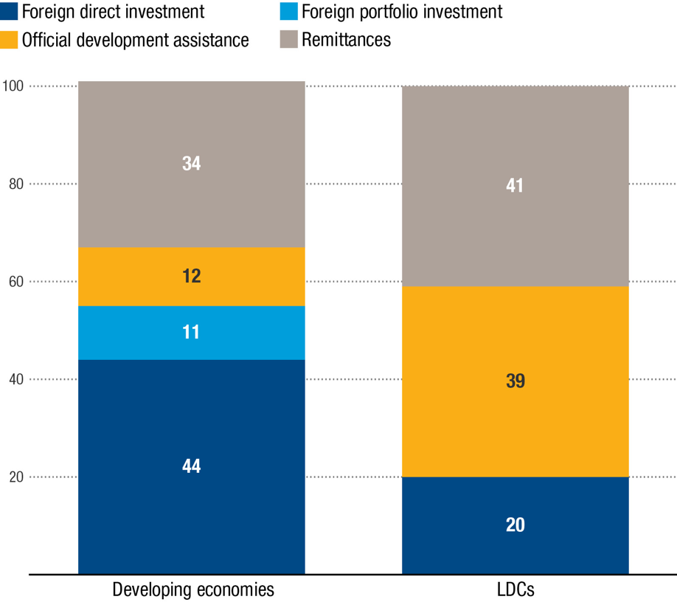
Source: UNCTAD.

However, global FDI flows have declined over the past decade amid an economic slowdown and rising geopolitical tensions. Investor uncertainty and tighter financial conditions, combined with the fracturing of the global economy, have negatively affected FDI flows, as well as international project finance deals and cross-border mergers and acquisitions.
FDI flows have increased by 17 per cent in developing countries, while they have declined by nearly 20 per cent in LDCs between 2015 and 2023. Although investment in renewable energy and infrastructure sectors has grown since the launch of the SDGs, investment in areas such as water, sanitation and health (WASH), and agrifood systems has decreased (figure 2). As a result, the overall SDG investment gap has widened from an estimated $2.5 trillion in 2015 to more than $4 trillion per year (UNCTAD, 2023).
Developing countries continue to prioritize investment attraction as part of their economic development strategies. The proportion of policies favourable to investors in developing countries has remained stable at well above 80 per cent since 2015, except for a low point registered during the pandemic.
Developing countries are also exploring opportunities to leverage institutional investment. Many developing economies have established or are in the process of establishing sovereign wealth funds (SWFs) as an important tool to catalyze investment for development. Developing countries are also seeking co-investments with sovereign funds and development finance institutions from other countries and are potentially attracting private and portfolio financing from pension and sovereign funds, including through the provision of junior capital to improve the risk-return profiles of projects or through sustainable financial products, such as green bonds. As yet, the share of developing countries in these investments remains small.
Structural issues constrain domestic and foreign private investment. These include limited productive capacities, challenges to accessing markets and finance, as well as skills and infrastructure weaknesses. The high cost of capital also remains a key barrier for attracting sustainable investment in developing countries.
There are concerns that tightening global tax rules could deter some forms of foreign direct investment, particularly where MNEs have benefited from generous tax incentives. For instance, the OECD/G20 global minimum tax could lead to a 2 percent reduction in global FDI (UNCTAD, 2022). For developing countries, the challenge lies in balancing the imperative of achieving greater tax justice with maintaining an attractive investment climate.

Figure 2
Developing countries: investment in sectors relevant to the sustainable development goals
Project numbers, percentage change between 2015 and 2023

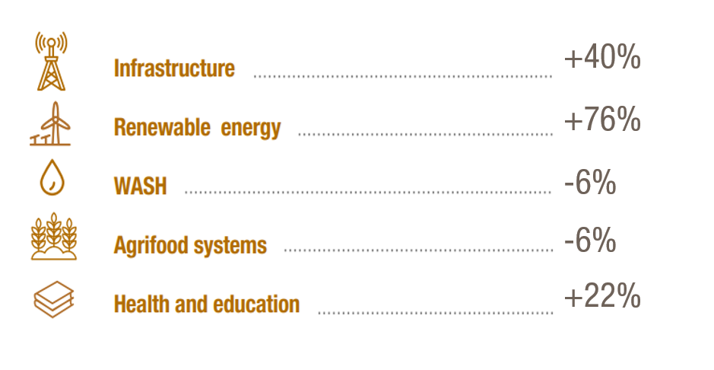

Source: UNCTAD.

At the global level, the distribution of investment between sectors has also changed, with FDI in services increasing from 65 per cent to 81 per cent over the last two decades, while manufacturing FDI has shown negative growth since the pandemic. This shift alters the development paradigm based on promoting investment in manufacturing export-led growth, affecting the prospects for developing countries to increase their participation in global value chains and to gradually upgrade to higher value-added industrial activities.
In this context, many countries still need to put in place tailored strategies and policies to attract investment. Too often, they rely on traditional instruments, such as fiscal incentives, and operate within the framework of old-generation IIAs, which limits their ability to pursue public policy objectives and raises the risk of investor-State disputes (ISDS).
The availability of meaningful, reliable and globally comparable reports on the sustainability performance of entities is essential in attracting investment from domestic and foreign investors, as well as to sustain access to global value chains. Over the past few years, progress has been made in developing sustainability reporting and related requirements. However, challenges remain. International sustainability reporting standards can have significant spillover effects for companies in developing markets, making it a priority to develop and implement technical assistance capacity-building, for entities to be able to comply with the new requirements. There is a need to avoid growing resistance to sustainable investment strategies in financial markets and, more broadly, to sustainability and disclosure requirements. Therefore, it is essential for policymakers to find a balance between promoting transparency and avoiding undue burdens on businesses.
Moreover, increasing regulatory demands for sustainability disclosure and reporting will determine not only investor choices and confidence in developing and emerging markets but will have indirect spillover effects for companies in the supply chains of MNEs. There are concerns that many countries and companies do not have the reporting infrastructure in place or resources available to meet the new requirements, which can be fragmented and complex.

Policy solutions (500 words)
Promoting international investment to achieve the SDGs is a significant challenge for developing countries, which requires a comprehensive policy shift, including:
- Global commitment to a stable, open and transparent investment environment. A renewed global commitment to an open and transparent investment environment is crucial to foster trust and attract long-term investments. It is important to strengthen national and regional investment environments. Recent FDI trends, including global value-chain restructuring, economic fracturing and nearshoring, have intensified the competition for FDI. Added to the sustainability imperative, these require countries and regions to adapt their strategies and enhance their environments to mobilize more quality investment.
- Enhance Investment Facilitation and digital government: These are important tools to attract and retain investment. By streamlining procedures, enhancing transparency and leveraging digital tools such as online single windows, countries can foster a more conducive investment climate, particularly in developing countries, which can address underlying weaknesses in governance and institutions and reduce country risk.
- Fostering innovative partnerships on risk-sharing among governments, MDBs, and the private sector, promoting the use of innovative financial instruments and targeted investment incentives. This also encompasses better leveraging de-risking tools such as investment guarantees, blended finance, and financial support (e.g. loans, grants, subsidies, or direct equity participation). This should be complemented by improving the Public-Private Partnership (PPP) in developing countries, e.g. in structuring and managing PPPs more effectively. This comprehensive approach can help mobilize the necessary capital and expertise.
- Systematic efforts to advance implementation of sustainability disclosure and assurance standards and address greenwashing. The persistence of greenwashing has demonstrated that more systemic efforts are needed to tackle the issue, including well-defined sustainability standards, disclosures, external auditing and third-party ratings. More consensus-building and capacity building efforts geared towards harmonization and full inter-operability of sustainability disclosure and assurance standards are necessary.
- Fast-tracking reform of IIAs. Old-generation IIAs continue to dominate and form the basis of most investor-State dispute settlement cases. Fast-tracking IIA reform is necessary to ensure that the IIA regime works for – rather than impedes – sustainable development objectives.
- Building capacity to design bankable projects in sectors aligned with the SDGs. Investors increasingly demand investment-ready projects, viewing them as essential tools for making informed decisions about potential ventures and their locations. These projects also provide an opportunity to integrate sustainability criteria from the outset, ensuring that environmental and social considerations are embedded in the planning stages.
- Support developing countries to respond to historic shifts in the investment – tax landscape. Many institutions face challenges not only in evaluating policy options and implementing complex international tax reforms but also in adjusting investment strategies accordingly. International support and technical assistance will be essential to help them realize the benefits of these reforms while minimizing any negative impacts on private investment for sustainable development.
- Leverage sovereign wealth funds (SWFs) and institutional investors: SWFs and institutional investors possess substantial capital that can be directed toward strategic infrastructure and SDG-related projects. Leveraging these funds can address investment gaps, if a portion of their assets can be allocated to large infrastructure and SDG projects. More de-risking initiatives need to be developed to leverage this long-term institutional investment. Additionally, in many developing economies, SWFs remain largely portfolio investors and face an urgent need to transform into strategic investors in key SDG sectors. Policy and technical support will be needed to facilitate this transformation.
- Support for outward investment from developed countries. The number of countries that actively promote outward investment to developing countries remains limited. This highlights an opportunity to expand outward investment programmes that support international development by facilitating domestic enterprises to engage in overseas investments that contribute to sustainable development in the countries.
Specific recommendations for FfD4 (300 words)
- Establishing a UN-led Task Force on Sovereign wealth funds (SWFs) and institutional investors, build on the UNCTAD Sustainable Institutional Investor platform. The task force should work with the full range of investment policymakers and MDBs/DFIs and private investors to:
  - Facilitate knowledge-sharing and foster partnerships and collaborations; advocate for policies and initiatives that promote sustainable investment.
  - Pool resources and expertise to co-invest in large infrastructure and SDG projects;
  - Support governments in developing robust risk-reduction frameworks and credit enhancement mechanisms.
  - Advice and capacity building to help governments to structure and manage PPPs.
- Creating an Investment Readiness Accelerator, hosted by UNCTAD: This would assist developing countries in assessing and removing legal and institutional obstacles to the attraction of investment in key priority sectors and in developing sector-specific strategies and facilitation tools; support investment facilitation and digital government solutions to improve transparency, and enhance the overall investment climate.
- Launch a multi-Stakeholder initiative for IIA reform. Coordinate efforts among UN agencies, and other stakeholders to reform outdated IIAs, focusing on expanding policy space for SDG-related measures and incorporating safeguards for public policy objectives
- Expand outward FDI promotion: This would involves increasing the availability of political-risk insurance and other outward FDI promotion tools, improving sustainability criteria and reporting of export credit agencies.
- Establish a consultative group on further harmonization of sustainability disclosure and assurance standards and on addressing greenwashing, built on the current work of UNCTAD’s Inter-governmental Working Group of Experts on International Standards of Accounting and Reporting (ISAR), to provide more resources on consensus building, capacity building and more education and training of preparers and users of sustainability reports.

Summary (75 words)
Global FDI flows declined since 2015, hindering progress towards the SDGs. FfD4 should seek to leverage partnerships between investment stakeholders, enhance countries’ readiness to attract investment in SDG, and promote home-country initiatives to channel investment. SWFs and institutional investors possess substantial capital that can be directed toward infrastructure and SDG, while more de-risking initiatives need to be developed. Systematic efforts to advance sustainability standards and address greenwashing is essential to grow sustainable finance.

UNCTAD (2023). World Investment Report 2023: Investing in sustainable energy for all. United Nations publication. Geneva.
UNCTAD (2022). World Investment Report 2022: International tax reforms and sustainable investment. United Nations publication. Geneva.

