**Financing Policy Brief Series – Recommendations for FfD4**

# **Better Monitoring of Health Spending to Advance Toward UHC**

## **Key messages**

* The SDG target for universal health coverage (UHC)—ensuring that all people have equitable access to good-quality health services without financial hardship (SDG Target 3.8)—is off track. People in vulnerable and marginalized situations, especially in low- and middle-income countries, are experiencing the greatest adverse impacts.
* Both the level and composition of health spending matters: domestic public funding is key for advancing toward UHC because it is strongly linked to improved coverage of essential services and reduced financial hardship. External aid remains critical for many low- and lower-middle-income countries.
* Effective monitoring of health spending patterns and trends at the country level is crucial for shaping the policies and investments to meet the SDG targets. Health accounts serve as the international standard for tracking health resources at the country level, offering a comprehensive and standardized insight into the level and composition of health spending and trends over time.
* WHO is committed to working with partners to support countries in strengthening their capacity to routinely, reliably, and accurately track health expenditure via health accounts and manage the largest repository of health accounts, the Global Health Expenditure Database (GHED), a global public good.

## **Problem statement**

At the midpoint of the 2030 target for the Sustainable Development Goals (SDGs), progress towards achieving universal health coverage (UHC)—ensuring that all people have equitable access to good-quality health services without financial hardship (SDG Target 3.8)—is *off track*.[1] Over 4.5 billion people, more than half of the global population, still lack full coverage for essential health services. Financial protection is also worsening, with two billion people experiencing financial hardship due to out-of-pocket (OOP) health costs.

People in vulnerable and marginalized situations, especially in low- and middle-income countries, are experiencing the greatest impact. Despite sharp increases in health spending across all income groups between 2000 and 2021, the proportion of the global population living in countries that spend less than US$100 per capita on health (from all sources, in constant 2021 prices) has remained steady at around 40 percent.

Government spending on health, which is crucial for advancing toward UHC, also remains highly uneven. In 2021, the average amount spent by governments on health per person in high-income countries (US$ 2,923) was substantially greater than that of upper-middle-income countries (US$ 298), lower-middle-income

countries (US$ 68), and low-income countries (US$ 10). Critically, the gap in government health spending between low-income countries and the rest has worsened over time. For most of this century, growth in government spending on health in low-income countries has been below that in other income groups (Figure 1). These severe inequalities indicate that, notwithstanding pledges to ensure no one is left behind, billions of people live in countries struggling to meet even basic healthcare needs.[2]

**Figure 1 Government spending on health per capita grew slower in low-income countries than other income groups during the Millennium Development Goals period and between the adoption of the Sustainable Development Goals and the pandemic.**

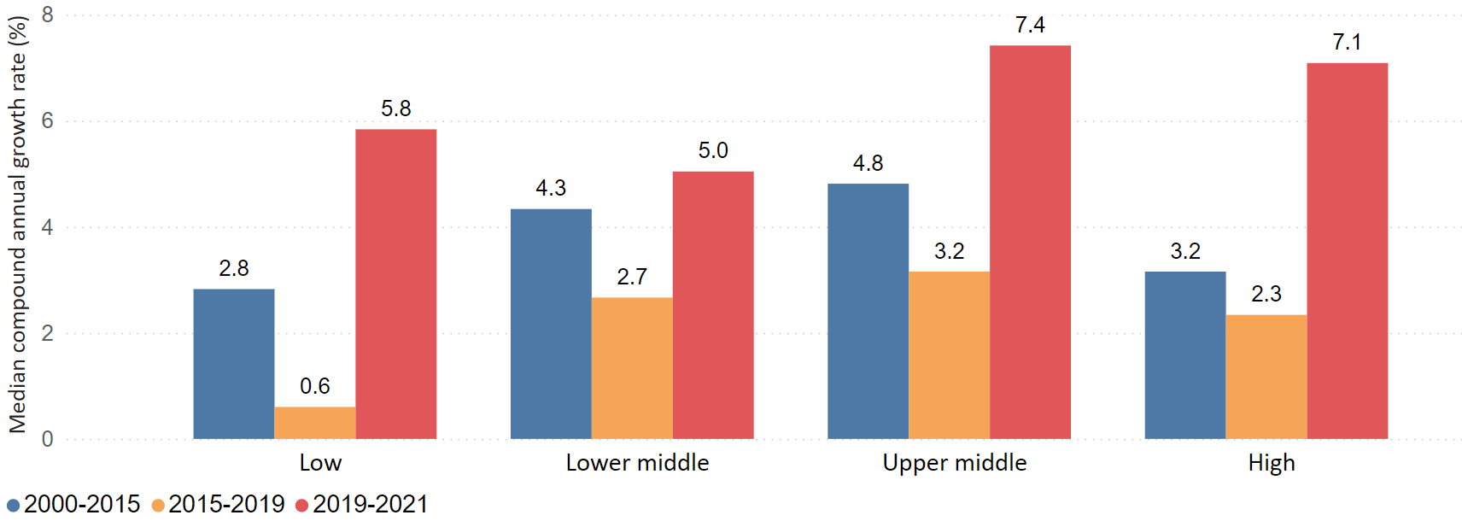

Note: Growth rates are based on per capita values in constant (2021) national currency units. Country-specific GDP deflators were used to convert current values to constant values. The median is used rather than the mean to avoid the domination of extreme values.   
Data source: WHO Global Health Expenditure Database, 2023.

Among low-income and lower-middle-income countries, the share of health in government spending has remained largely unchanged on average since 2000 (Figure 2). Accordingly, growth in health spending has been driven by economic growth, combined with efforts to raise additional public revenue in these countries rather than health rising as a priority. In contrast, health has generally increased in priority within government budgets in upper-middle-income countries and high-income countries over the same period. These trends continued through the pandemic.

Without increases in government spending in low- and lower-middle income countries, out-of-pocket (OOP) spending and health aid are significant sources of health revenues. In 2021, nearly 70 percent of health spending in low-income countries was financed by a combination of OOP spending and external aid (of which 31 percent was health aid), whereas in lower-middle-income countries, it was 52 percent (of which 14 percent was health aid).

Both sources of funding present challenges for advancing toward UHC. OOP payments for health are a highly inequitable form of financing as they tie people’s access to health services to their ability to pay, contributing to financial hardship. There are persistent difficulties aligning external aid to national priorities and channelling

aid through national financial systems, which limits its effectiveness as a complement to government spending in contexts where government capacity is limited.

**Figure 2. Out-of-pocket spending and health aid play a significant role in financing health in low and lower-middle-income countries**

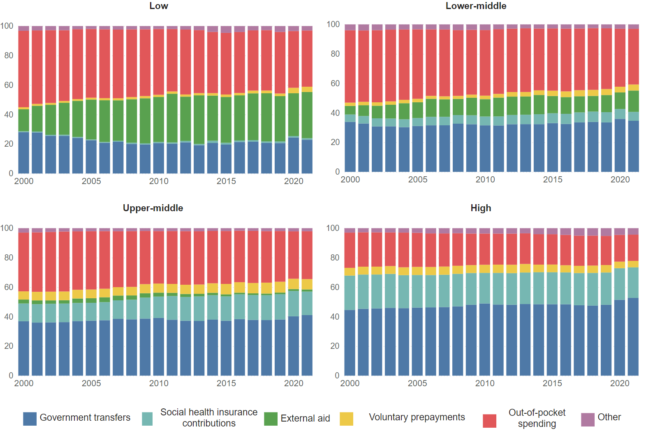

Data source: WHO Global Health Expenditure Database, 2023.

## **Policy solutions**

**More government funding for health and better quality spending**

Additional government funding for health is essential for advancing toward UHC, as it is strongly linked to improved coverage of essential services and reduced financial hardship. Private sources of financing, such as voluntary health insurance and out-of-pocket payments, should only be supplementary.

However, countries face an increasingly challenging funding environment. Economic headwinds and narrowing fiscal space mean that historical links between growth and spending cannot be taken for granted. Additionally, emerging issues like aging populations, urbanization, and changing lifestyles are expected to strain health systems, increasing demand for long-term care and management of multi-morbidities. Additionally, rising age-dependency ratios for old age can have significant implications for the sustainability of health revenues, particularly among countries dependent on revenues from contributions to social health insurance schemes linked to the labour markets.

Thus, in addition to boosting public funds, countries face the task of finding ways to improve the equity and efficiency of health spending. At the core of this is the prioritization of primary health care (PHC), which is essential for addressing both current and emerging health challenges and crucial to an equitable and efficient health system. Additionally, funds should be targeted at protecting the most vulnerable populations and ensuring no one is left behind.

While aid is essential for addressing funding gaps in low- and lower-middle-income countries, it should complement rather than replace government spending. Additionally, health aid should be predictable and aligned with national priorities.

**Better monitoring of health spending to get countries back on track**

To improve global and national decision-making during this challenging period, it is important to monitor health spending trends and patterns in relation to the SDG health targets. Health accounts, which follow the System of Health Accounts (SHA) 2011, serve as the international standard for tracking health resources at the country level. By offering comprehensive data on health sector spending—covering how much is spent, the sources of funding, and how the money is used— health accounts can provide policymakers with critical insights into the level and composition of health spending and trends over time. These can help guide health financing policy and investment decisions, improve transparency, and enhance accountability.

Moreover, the standardized SHA 2011 framework enables benchmarking against peer countries. While each health accounts is a snapshot, consistent reporting over time allows these snapshots to be combined, revealing valuable trends in health system dynamics.

Health accounts data from more than 190 countries is stored in the WHO’s Global Health Expenditure Database (GHED), which also provides time series information from the reference year 2000 through 2021. As the world’s largest repository of health spending, the GHED serves as an essential global public good. The WHO updates the database annually and works with countries to ensure the validity and accuracy of the data. The database has grown over time to include more countries and indicators, and this expansion is expected to continue. It is relied upon by a wide range of users for analytical and policy purposes, including (but not limited to) governments, development partners (including WHO, the World Bank, IMF, the Global Fund, Gavi, regional development banks and other multilateral and bilateral agencies and global health initiatives), academia and civil society.

Currently, data availability is a significant barrier to the effectiveness of health accounts and the completeness of the GHED. While many countries report aggregated health spending data, some still find it difficult to produce timely data. Additionally, detailed reports are relatively rare. These challenges limit the capacity to effectively analyze health spending dynamics.

As health accounts become more institutionalized, the more likely countries will be able to produce complete, reliable and timely health expenditure data aligned with international standards. While each country’s approach to institutionalization will differ, countries with well-established health accounts share common traits: the process is country-led, staff and data collection are funded by domestic government resources, teams can routinely access essential health spending data (often through digital systems), and there are coordination mechanisms in place to work with various data-providing stakeholders.

**Specific recommendations for FFD4**

The Universal Health Coverage (UHC) targets in the SDGs remain an achievable goal. However, to get back on track, countries must increase public spending on health per capita and ensure that private funding plays a supplementary and complementary role. In many low- and middle-income countries, development assistance will continue to be a crucial source of financing for the foreseeable future. Therefore, efforts must focus on improving the alignment and predictability of this assistance.

Effective health resource tracking via institutionalized health accounts is also critical to achieving the SDG health targets. Accordingly, member states should require health accounts are regularly produced; provide adequate and sustainable funding from the government budget, where feasible, for well-trained teams, and build the systems to allow these teams to routinely access data and coordinate with data-providing and data-using stakeholders. Regularly producing high-quality health accounts and integrating the results into national, regional and international monitoring systems can stimulate a virtuous cycle that creates greater analytical demands for better quality of data.

Partners, including donors and supranational bodies, have an important role to play in promoting the institutionalization of health accounts. By advocating for the regular production of health expenditure statistics and investing in technical assistance, external partners can drive the development of health accounts while also building local capacity and contributing to a global public good. Indeed, international obligations – e.g., that member states of the West African Monetary Union and European Union report SHA-based health expenditure data on an annual basis – are an important driver of HA production and examples of embedding health accounts within regional legal frameworks.

WHO is committed to coordinating activities (at the country, regional, and global levels) with partners to support countries with their health resource tracking and reporting. Additionally, the WHO will continue developing practical guidance and tools to improve the production and analysis of health accounts while maintaining the GHED as a valuable global public good.

**Summary**

This brief offers a global overview of health spending and highlights the critical role of health expenditure data in shaping policies to achieve the SDG health targets. It calls on countries and global partners to strengthen health expenditure tracking via health accounts to improve policymaking, enhance transparency, and promote accountability.

1. <https://www.uhc2030.org/who-we-are/governance/2024-2027-strategic-framework/>
2. WHO 2023. Global Health Expenditure Report 2023. Coping with the Pandemic. <https://apps.who.int/nha/database/DocumentationCentre/GetFile/62053151/en>