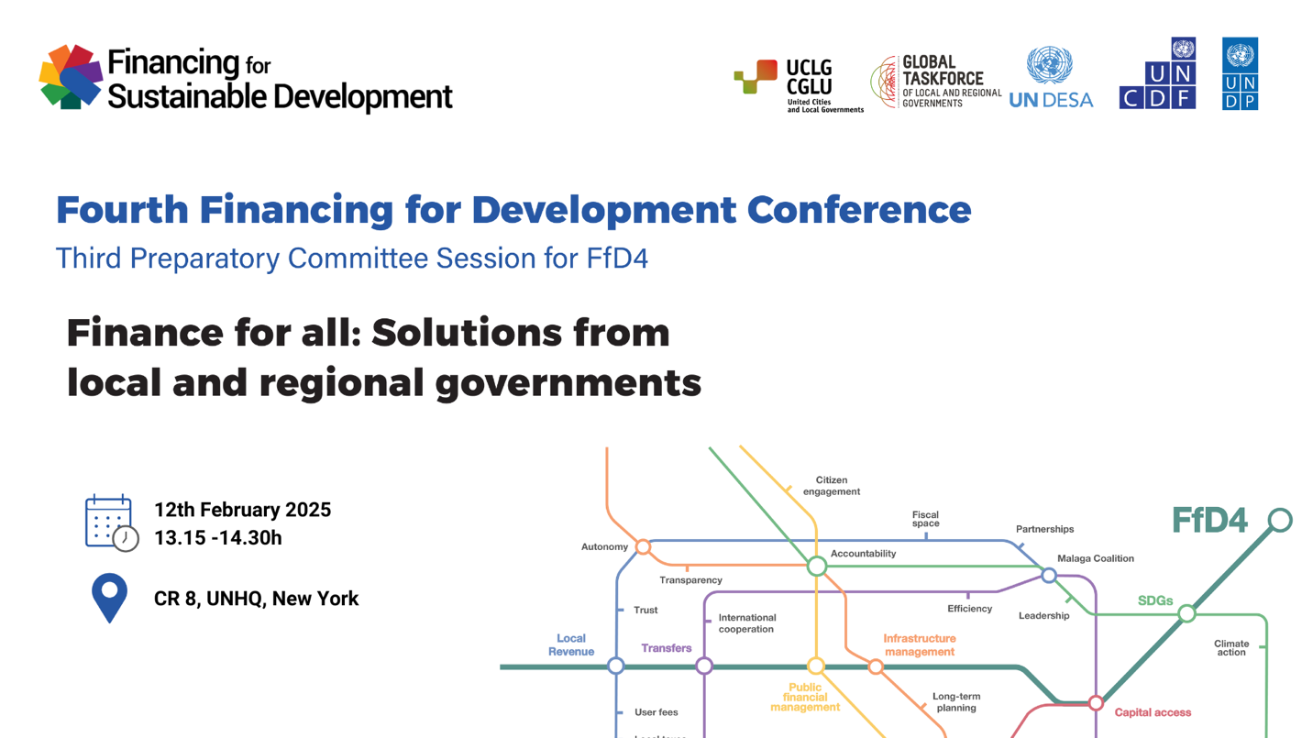
Organized by: United Cities and Local Governments, Global Taskforce of local and regional governments, UNDESA, UNDP and UNCDF.
The side event will be broadcasted at https://webtv.un.org/en
Background
Local and regional governments (LRGs) are pivotal in addressing global challenges, driving the localization of the 2030 Agenda, and achieving sustainable development. As key actors responsible for 39.5% of public investment worldwide and 65% of SDG indicators, their role in providing essential public services and fostering territorial equity is undeniable. As of 2020, subnational governments accounted for 21.5% of total public expenditure and 39.5% of total public investment, on the global average. However, public investment remains low compared to investments required to achieve the SDGs. Systemic barriers in the global financial architecture limit their ability to access the necessary resources, limiting their capacity to address the pressing realities of climate change, urbanization, and social inclusion.
The Addis Ababa Action Agenda (AAAA), in its Par. 34, adopted in 2015 recognized local finances as an important building block in sustainable development, and allowed for progress to be made in the last decade, with the surge of innovative financing mechanisms including subnational finances. The Fourth International Conference on Financing for Development (FfD4), scheduled for June 30 to July 3, 2025, in Sevilla, Spain, represents a decisive moment to advocate for reforms that prioritize LRGs and to reshape global financial systems to better address the challenges of achieving the Sustainable Development Goals (SDGs). As the AAAA declaration is in the course of being reviewed and revamped ahead of FfD4, the local and regional government organized constituency calls to build on innovative pilot mechanisms and improve the conditions and frameworks to channel affordable financing from public and private actors to subnational governments. Concrete and operational, yet ambitious calls for action directed to each and all actors of local finance-related global ecosystem is required to effectively give a chance to local and regional governments to implement transformative care policies based on a renewed social contract.
The Third Session of the Preparatory Committee for FfD4 builds on the First Session in July in Addis Ababa, the Multistakeholder Hearing in New York on 29 October and the Second Session in December 2024 at the United Nations Headquarters in New York. The Third Session of the PrepCom will largely be based on the zero draft of the Outcome Document of the FfD4 conference issued by the co-facilitators Nepal, Mexico, Canada and Norway and released on 17 January 2025. Each of the central topics that have structured the previous PrepCom sessions and the call for inputs to the Elements paper will be tackled in the discussions: domestic public resources, domestic and international private business and finance, international development cooperation, science, technology and innovation, international trade as an engine for development, debt and debt sustainability. Then crosscutting approaches will be put on the agenda such as systemic issues, data, monitoring and follow-up.
As did the Elements paper, the Zero Draft of the Outcome Document covers policy solutions, actions and reforms for Member States to consider and we welcome the paragraph dedicated to subnational finance. We note the proposal to enhance capacity building of local authorities to strengthen subnational finance and the role of local governments in sustainable infrastructure asset management. There is a mention of the importance in establishing a “whole-of-government approach” to the revision of fiscal frameworks and public financial management. Local and regional governments are the level of government closest to the citizens where accountability, transparency and trust in public institutions related to financial practices has the best ground to flourish on. The local governments’ knowledge of local realities can also be used to better orient the incorporation of the gender perspective and climate considerations into budgeting and financial planning as recommended in the Zero Draft.
However, there insufficient recognition of the crucial role that local and regional governments can play in shaping and mediating local financing for development in various aspects beyond domestic public resources, together with national governments, and non-governmental actors. On international development cooperation, country level policy alignment and financial planning is encouraged, with a distinctive and autonomous role of local and regional government, which should be part of integrated coordination. Particularly beneficial interactions can emerge from the joint work and alliance between subnational development banks that work with local authorities to on-lend or guarantee financing from larger international financial institutions with a knowledge of the local context.
As discussions and negotiations begin, aiming to agree on a final Outcome Document at FfD4 Conference, a roadmap of consultations has been elaborated and began on January 22 with a Permanent-Representative-level briefing for member states. Although a stakeholder hearing is to take place on February 7, the Global Organized Constituency of Local and Regional Governments finds itself limited to advocate and contribute beyond the inputs to the Elements paper, without a dedicated stakeholder role and space to participate as subnational government actors in the negotiations.
Objective of the side event
Present the concrete solutions that local and regional governments are proposing to the FFD4 to discuss on how local government finance can contribute to finance sustainable development.
These concrete and constructive proposals have been developed together with the contribution of UNDESA, UNDP and UNCDF and are research based.
This side event wants to bring attention to the following issues:
- How new alliances and complementary mechanisms such as city-friendly investment funds and risk-mitigation or guarantee facilities local financing solutions can help breking the gridlock of local government finance.
- How investment through local governments boosts sustainable economic growth across the country and mitigates territorial inequalities.
- How local governments contribute to creating trust in the public sector and reduce the potential for conflict.
- How improving the public financial and public infrastructure asset management capacities of local governments is critical to achieving the SDGs.
It is encouraged for the participants and speakers to emphasize the critical need to reform the global financial ecosystem to empower local governments. This session aims to demonstrate how innovative and inclusive financing mechanisms can transform the global financial landscape, ensuring that local governments are equipped to drive sustainable, equitable development for all.
Agenda (1.30h session)
Moderation and welcome (5 min) | Caroline Lombardo, Chief, International Tax and Development Cooperation Branch, Financing for Sustainable Development Office  United Nations Department of Economic and Social Affairs
Opening remarks (8 min) | Jan van Zanen, Mayor of The Hague (Netherlands) and President of United Cities and Local Governments (video message)
Panel discussion (8 min each, 30 min total) | Navid Hanif, Assistant Secretary-General for Economic Development in the Department of Economic and Social Affairs (DESA)  Marcos Neto, Assistant Secretary-General and Director of UNDP’s Bureau of Policy and Programme Support, UNDP  UNCDF representative
Presentation of the Policy brief “Breaking the SDG finance gridlock through strengthening local government finance” (6 min) | By UNDESA, UNCDF and UNDP technical teams.
Interactive discussion (30 min) with panelists and respondents | Paul Smoke, Professor of Public Finance and Planning, NYU Wagner Graduate School of Public Service  Representative from a UN member state  Marina Ponti, Director, UN SDG Action Campaign
Closing remarks (5 min) | Caroline Lombardo, Chief, International Tax and Development Cooperation Branch, Financing for Sustainable Development Office  United Nations Department of Economic and Social Affairs

