Concept Note for Side Event at FfD4 Third PrepCom Session
February 12, 2025 |(10:00-11:30 New York time (EDT))

Contribution of Supreme Audit Institutions to Digitalization in Developing Countries
Abstract
Digitalization is reshaping governance, public financial management, and service delivery worldwide. In developing countries, the adoption of digital tools presents both opportunities and challenges for accountability and transparency. Supreme Audit Institutions (SAIs) play a crucial role in ensuring that digital transformation efforts align with good governance principles, cybersecurity standards, and data privacy regulations.
This side event will explore how SAIs are contributing to digital transformation and governance in their countries by exercising independent external oversight. It will also build on insights from the Global Summit on SAI Audits Contributing to Digitalization and Sustainability, held on November 18–19, 2024, in Tbilisi, Georgia, where leaders of SAIs and international organizations discussed the intersection of digitalization, sustainability, and public sector accountability. By connecting these discussions to the Financing for Development (FfD) agenda, the session will highlight ways SAIs contribute to digital governance and inclusive economic growth.
Background
Governments in developing countries are increasingly leveraging digital platforms to improve public service delivery, financial management, and social protection systems. However, these digitalization efforts come with risks, such as cybersecurity threats, challenges in data governance, and inequalities in access to digital services.
SAIs, as independent oversight institutions, must develop new capabilities to audit complex digital ecosystems effectively. The Global Summit on SAI Audits Contributing to Digitalization and Sustainability underscored the urgency of expanding SAIs' technology audit scope, enhancing their use of AI-driven audit tools, and strengthening international collaboration to build technology audit capacity.
This side event will discuss real-world experiences from SAIs that have audited digital transformation initiatives in their respective countries, focusing on their impact, challenges, and future strategies.
Objectives
This side event aims to:
- Examine the role of SAIs in auditing and supporting digital transformation efforts.
- Highlight case studies of audits of digitalization conducted by SAIs in key sectors such as social protection, service delivery, and cybersecurity.
- Explore challenges and opportunities in auditing digital governance systems, including data privacy, inclusion, and accountability.
- Facilitate knowledge-sharing among SAIs, development agencies, and international organizations on advancing digital public sector audits.
Expected Outcomes
- Greater awareness of the importance of SAIs in ensuring responsible digitalization.
- Deeper insights into the impact of audits of digitalization on governance, inclusion, and financial management.
- Stronger collaboration between SAIs, development organizations, and stakeholders in digital governance.
- Identification of strategies for sustaining and scaling SAI-led audits of digitalization .

Structure and Format
The session will feature a panel discussion and a plenary dialogue, engaging representatives from key SAIs and the INTOSAI Development Initiative (IDI).

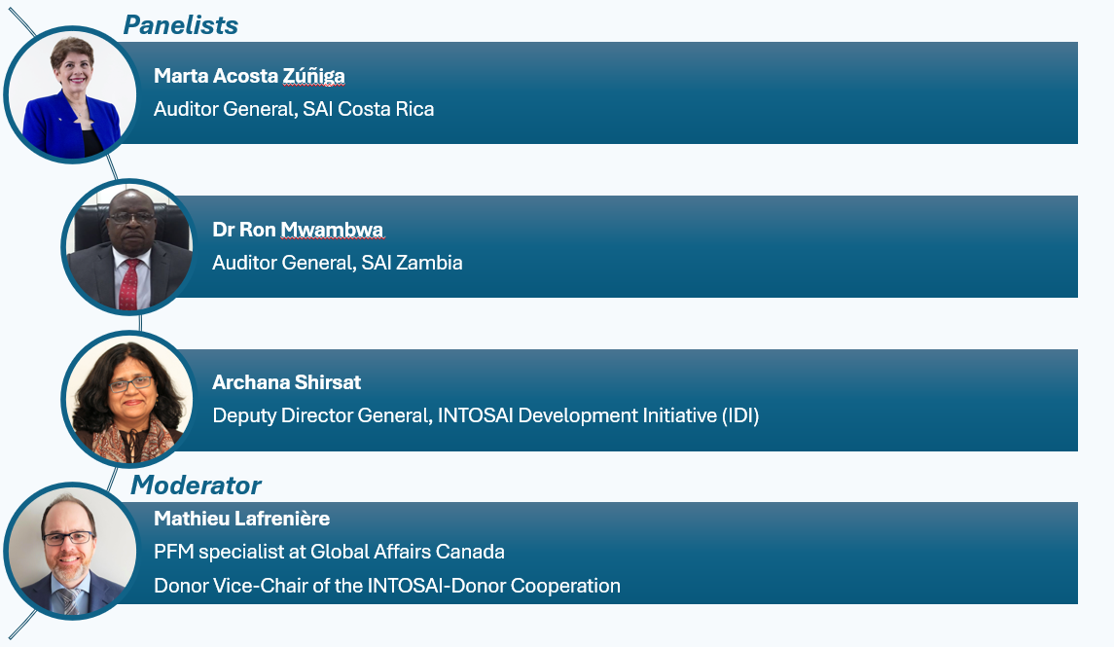

Conclusion
This side event will provide an opportunity for SAIs and stakeholders to exchange knowledge on how digitalization is reshaping public financial management and governance. By drawing insights from recent global discussions, particularly the Global Summit on SAI Audits Contributing to Digitalization and Sustainability, the session will highlight best practices, challenges, and future directions in auditing digital transformation efforts.
Through continued collaboration and innovation, SAIs can enhance their capacity to audit digital systems effectively, ensuring that digitalization contributes to transparency, accountability, inclusion and sustainable development.

