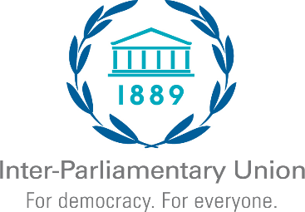

**Parliamentary event at the FFD4**

***Taking stock of deliverables; mobilizing parliaments into action***

**Wednesday, 2 July, 12:30 – 14:00**

**Venue: FIBES 1**

10:00 **Welcome and introduction**

IPU Representative to introduce and moderate

10:10 **Parliamentary oversight of development finance: key modalities and trends**

Parliaments occupy a unique space between governments and citizens, providing them with opportunity to align financing efforts to the needs of people, show political leadership, and drive inclusive development. Most critically, parliaments have a constitutional responsibility to hold governments to account for their commitments on development finance, particularly through the key budget process. This segment will consider the main tools and modalities parliaments can make use of to strengthen their oversight of development finance flows such as aid, debt, taxes and private investments.

Discussant (10 min):

**Ms. Ana Patricia Munioz**, Executive Director, International Budget Partnership (IBP)

Q&A (10 min)

10:30 **The FFD4 outcome document: a parliamentary assessment**

The financing gap for the SDGs has widened significantly over the last few years and, barring major reforms, can be expected to increase. The latest estimates indicate a shortfall of $4 trillion a year to be mobilized from a mix of public and private sources. Reform proposals have been on the drawing board for well over two decades with only mixed results showing at best. With this scenario in mind, last year’s Pact for the Future called for a transformative outcome document to come out of the FFD4. This session will assess the extent to which such an outcome has been realized including through the prism of the recommendations that parliamentarians developed at the 2025 Parliamentary Hearing at the United Nations.

Leading questions:

* Do commitments taken at FFD4 go far enough?
* How can parliamentarians help advance the FFD agenda going forward?

Discussants (5-7 min. each):

**Member of Parliament (tbc)**

Review of aid and debt commitments and recommended actions

**Member of Parliament (tbc)**

Review of trade and investment commitments and recommended actions

**Member of Parliament (tbc)**

Review of commitments on domestic resource mobilization (taxation) and recommended actions

Debate with participants (40 min)

11:20 **Final remarks and closing**