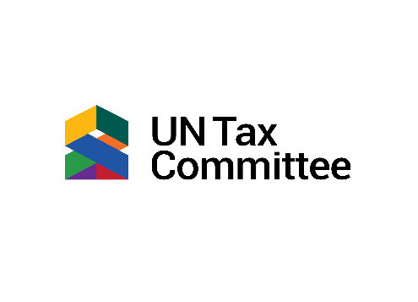
UNTC 31st Session

Stakeholder Input Template
Help inform the Committee’s deliberations on their work programme for 2025-2029 by sharing your perspectives on challenges in tax policy and administration facing developing countries, emerging issues that need attention, and where there is a need for more or different guidance. Submissions should be made in one of the six (6) UN languages. All valid submissions will be published on the UN Tax Committee website in the language submitted.
Submission details: Deadline: 1 September 2025, Email to: taxcommittee@un.org
Subject: Input for UN Tax Committee Work Programme (2025-2029)
INFORMATION
Contact Person: Click or tap here to enter text.
Email: Click or tap here to enter text.
Type: Choose an item.
Organization (unless submission is in personal capacity): Click or tap here to enter text.
BACKGROUND (Maximum of 200 words) – Please respond on page 2.
Please provide a brief summary of your organization’s mandate and areas of work unless this submission is in personal capacity, how they relate to international tax cooperation, domestic resource mobilization, sustainable development, or any other field. This will help us map and better contextualize your perspective and input.
WORK PROGRAMME PRIORITIES (Maximum of 2000 words inclusive of any footnotes) – Please respond on page 3.
What should be the Committee’s priority issues for 2025-2029? Consider, in light of the Committee’s mandate, both the provisional agenda topics and any additional areas you believe are important.
For each priority you recommend, please explain:
- Why is this issue important for developing countries?
- What specific guidance or tools should the Committee produce?
- How would this output be practical and valuable for countries?
SUPPORTING REFERENCES Please list any hyperlinks to relevant reports, studies, or other materials that support your recommendations. Do not attach files. – Please respond on page 4.
BACKGROUND (Maximum of 200 words)
Please provide a brief summary of your organization’s mandate and areas of work unless this submission is in personal capacity, how they relate to international tax cooperation, domestic resource mobilization, sustainable development, or any other field. This will help us map and better contextualize your perspective and input.

WORK PROGRAMME PRIORITIES (Maximum of 2000 words inclusive of any footnotes)
What should be the Committee’s priority issues for 2025-2029? Consider, in light of the Committee’s mandate, both the provisional agenda topics and any additional areas you believe are important.
For each priority you recommend, please explain:
- Why is this issue important for developing countries?
- What specific guidance or tools should the Committee produce?
- How would this output be practical and valuable for countries?

SUPPORTING REFERENCES Please list any hyperlinks to relevant reports, studies, or other materials that support your recommendations. Do not attach files.

