**THE ROLE OF RENEWABLE ENERGY TECHNOLOGY IN ENHANCING GREEN BUILDING PROJECTS IN NIGERIA**

**Benjamin Anabaraonye1 Nnamaka.U.Nzewi2 Nzemeka.C.Olisah3**

1. **University of Nigeria, Nsukka, Nigeria. Email:** [**benjaminshines@gmail.com**](mailto:benjaminshines@gmail.com)

**2. Nnamdi Azikiwe University, Awka, Nigeria. Email:** [**nu.nzewi@unizik.edu.ng**](mailto:nu.nzewi@unizik.edu.ng)

**3. Nnamdi Azikiwe University, Awka, Nigeria. Email: nc.olisah@unizik.edu.ng**

**ABSTRACT**

In recent years, there has been a growing realization of the need to prioritize climate action and sustainable development in the construction sector. This has given rise to the imperative of promoting green building practices for enhancing climate resilience in Nigeria's construction industry. Green building, often referred to as sustainable or eco-friendly construction, represents a paradigm shift in the way buildings are designed, constructed, and operated. It entails the integration of environmentally responsible and resource-efficient strategies throughout a building's lifecycle. This study identifies that the integration of renewable energy technology is an innovative strategy in enhancing the green building projects in Nigeria. Solar energy, wind energy, and other renewable energy sources are being harnessed to power buildings, reducing reliance on non-renewable energy sources and lowering greenhouse gas emissions. Green building practices are of utmost importance in Nigeria for promoting environmental [sustainability](https://constructive-voices.com/episodes/) and harnessing the potential of renewable energy systems. This study recommends international development cooperation and green financing from multilateral organizations such as the World Bank Group(WBG) and the United Nations Environment Programme(UNEP) towards enhancing green building projects in Nigeria. It concludes with a clarion call for deeper research on the role of renewable energy technology in enhancing green building projects for climate resilience in Nigeria.

**Keywords: Climate Change, Co-operation, Education, Green Building, International Development, Renewable Energy, Resilience.**

**INTRODUCTION**

Climate change is the most significant challenge to achieving sustainable development, not only because it affects the global physical environment directly, but also because it affects nearly all aspects of socio-economic development (Anabaraonye, Okafor & Eriobu, 2019). Climate change has been described as an existential threat to human well-being. Globally, it affects the social and environmental determinants of health: clean air, safe drinking water, sufficient food and secure shelter. The effects of climate change are far-reaching and include heat waves and severe weather, deteriorated air quality, displacement and migration of vectors resulting in increase of a range of diseases related to water and ecological factors. Increasing incidences of mental health issues are being recorded and identified as a consequence of environmental change (LU, 2016, PAHO,2013). Researchers have recently identified the impacts of climate change on biodiversity in Nigeria (Anabaraonye, Amaechi, Okolo, Adeniyi & Nwobu, 2022). The impacts of climate change which includes flooding, land pollution, erosion, etc. also affects soil fertility in Nigeria in a profound way(Anabaraonye, Okafor, Ewa & Anukwonke, 2021). Green entrepreneurial opportunities abound in the green building projects for enhancing climate resilience and sustainable economic growth in Nigeria(Anabaraonye, Okafor & Eriobu, 2019). Awareness creation through green entrepreneurship education will certainly help individuals, communities and institutions in Nigeria to maximize the economic, social and environmental benefits of green building projects in Nigeria(Anabaraonye, Okon, Ewa, Adeniyi & Nwobu, 2022).Researchers have recently identified the disruptive innovation and green entrepreneurial opportunities in the renewable energy industry in Nigeria(Anabaraonye, Onnoghen, Orji, Ewa & Olisah, 2024).This study identifies the role of renewable energy technology in enhancing green building projects for sustainable development in Nigeria.

**METHODOLOGY**  
Generally, this paper aimed to examine the role of renewable energy technology in enhancing green building projects for sustainable development in Nigeria. This paper examined current progress with the use of renewable energy which is a climate change mitigation strategy for sustainable development in Nigeria through existing literature review. It also identified the innovative ways of educating communities and institutions in Nigeria on the benefits of the green building projects and the role of renewable energy technology in advancing the projects for sustainable development in Nigeria.

**THE CONCEPT OF GREEN BUILDINGS PROJECT IN NIGERIA**

Green building is a holistic concept that starts with the understanding that the built environment can have profound effects, both positive and negative, on the natural environment, as well as the people who inhabit buildings every day. Green building is an effort to amplify the positive and mitigate the negative of these effects throughout the entire life cycle of a building(Kriss, 2014). Green building, often referred to as sustainable or eco-friendly construction, represents a paradigm shift in the way buildings are designed, constructed, and operated. It entails the integration of environmentally responsible and resource-efficient strategies throughout a building's lifecycle. Green building is the practice of creating structures and using processes that are environmentally responsible and resource-efficient throughout a building's life-cycle from siting to design, construction, operation, maintenance, renovation and deconstruction. This practice expands and complements the classical building design concerns of economy, utility, durability, and comfort. Green building is also known as a sustainable or high performance building(EPA,2016). Green buildings incorporate measures that are environmentally friendly and resource-efficient across the building lifecycle. The green buildings concept aims to comprehensively minimize the negative impact and maximize the positive impact a building has on its natural environment and human occupants.

Green buildings are designed to reduce the overall impact of the built environment on human health and the natural environment by:

* Efficiently using energy, water, and other resources
* Protecting occupant health and improving employee productivity
* Reducing waste, pollution and environmental degradation

For example, green buildings may incorporate sustainable materials in their construction (e.g., reused, recycled-content, or made from renewable resources); create healthy indoor environments with minimal pollutants (e.g., reduced product emissions); and/or feature landscaping that reduces water usage (e.g., by using native plants that survive without extra watering) (EPA, 2016). Understanding the nature and extent of inefficiencies and negative impacts in the built environment helps drive the development of new approaches and technologies that can improve all aspects of a building’s performance. [Green buildings](http://www.pnnl.gov/news-media/sustainability-energy-research-included-spokane-smart-eco-district) are needed on a global scale to help drastically reduce greenhouse gas emissions, conserve increasingly stretched energy resources, and contribute to improved human health.

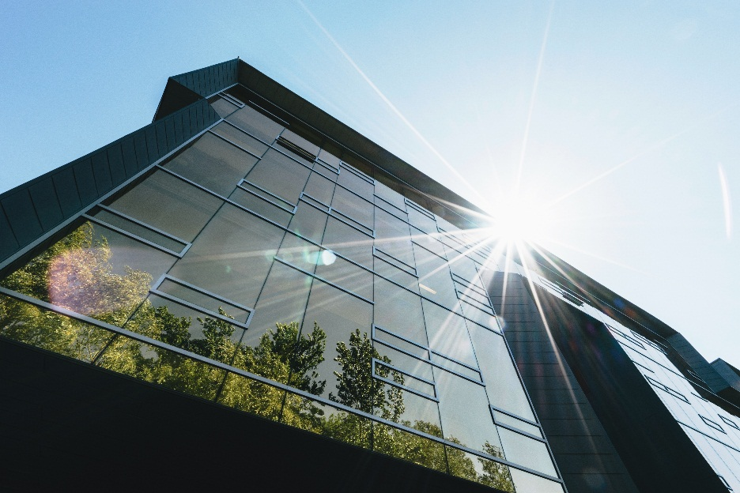

**FIG 1: Example of A Green Building**. Green buildings leverage elements of the natural environment combined with advanced techniques and technologies to improve performance over a building’s lifespan. (Photo by Scott Webb | Pexels.com

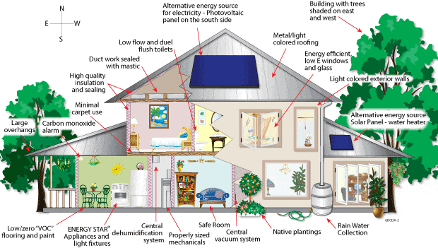

**Fig. 2: Green Building Concept; Residential Example. (Graphic: theconstructor.org)**

## GREEN BUILDINGS IMPORTANCE AND APPLICATIONS

The fundamental concern of green building projects from an environmental judgment suggests the effective control and management of natural occurring materials so as to uphold and conserve them for the future(Nwogu & Emedosi,2024). In the very early stages of seeing a building with environmental certification, layman's discernment is determined by the need for sustainability and belief in the building's level of certification. This is because it shows the environmental aspects of the design (Mansour & Radford, 2014). The focus of sustainability was initially on technical issues such as materials, building components, construction methods and energy-related design concepts. But attention is also shifting to non-technical matters, economic and social sustainability concerns, and the cultural heritage of the construction industry (Abolore, 2012). Each project or development comes with its own benefits, tasks and obstacles to success, and green construction projects in Nigeria are no exception. It is worth noting that green building requires distinct materials and frameworks to integrate sustainability compared to non-sustainable structure (Nwogu & Emedosi,2024). Sheth (2016) postulates that green building resources ought to be resource-efficient, energy-proficient, affordable and promote improved indoor air quality. According to Oluwadare (2018), it is the opinion of many writers that planning and designing with industrial materials and reusing construction and demolition materials produced from projects promotes green building projects. In the view of World Green Building Council, minimizing waste and maximizing reuse can be encouraged by incorporating highly durable material-resources that generates a smaller amount of waste and emphasizing on the need for green building projects which can be enhanced through the renewable energy technology(Nwogu & Emedosi, 2024).

Green buildings combine a variety of approaches—to practices, technologies, and materials—across all stages of a building’s lifecycle. The set of measures applied to a building is customized to that building’s unique situation and work together to optimally reduce its impact on the human and natural environment. Many of these approaches involve using renewable resources, as well as introducing techniques and technologies or using innovative materials that improve resource utilization. Maximizing energy, water, and materials performance are major drivers in configuring green buildings. The following examples are just a few of many options in the green builder’s toolbox, a list of measures that continues to grow and evolve with new knowledge and innovation(PNNL,2021).Researchers have recently identified the health benefits in the use of solar energy for sustainable development in Nigeria(Ajator, Anabaraonye & Ewa, 2020).Renewable energy sources, including solar, are often factored into green buildings. For example, some use photovoltaic panels for on-site solar power generation. Others employ passive solar building design strategies that physically position building elements, including windows, walls, awnings, and landscaping, to maximize the benefits of cooling shade in summer and solar warmth in winter.The concept of daylighting calls for orienting windows in a manner that makes best use of natural light inside the building and reduces electric lighting needs. And solar-powered water heating cuts down on energy costs(PNNL,2021). Plants and trees have also become firmly rooted within green building practices. They are used to create a form of “green roof” that helps manage rainwater, provides building insulation, and cools nearby urban air, among other benefits. They are also planted in “rain gardens” to filter pollution from stormwater runoff, allowing it to be redirected in various useful ways that ultimately conserve water and ease related infrastructure and environmental burdens. The importance of tree planting in enhancing climate resilience is worthy of note.

**UNDERSTANDING RENEWABLE ENERGY AND SUSTAINABLE DEVELOPMENT**  
  
Renewable energy is energy that is generated from natural processes that are continuously replenished. This includes sunlight, geothermal heat, wind, tides, water, and various forms of biomass. This energy cannot be exhausted and is constantly renewed(Ciolkosz, 2009). Renewable energy can also be defined as energy that is collected from renewable resources, which are naturally replenished on a human time scale, such as sunlight, wind, rain, tides, waves, and geothermal heat. Renewable energy often provides energy in four important areas: electricity generation, air and water heating/cooling, transportation, and rural(off-grid) energy services (Odinaka, 2012). Renewable energy (RE) and Sustainable development (SD) are two key expressions for human beings since fossil fuels tend to exhaustion, have higher and higher prices that are going to be unbearable for humanity and are the main factors  responsible for GHG emissions. Renewable energies, on the contrary, among other things, are clean and safe and are fundamental for sustainable development, the one that preserves resources for the future generations(Manso & Behmir, 2013) . The term ‘Sustainable Development’ has been popularized by the World Commission on Environment and Development(WCED), in its 1987 report entitled,‘Our Common Future’. The commission defined sustainable development as ‘the development that meets the needs of the present without compromising the ability of future generation to meet their own needs’ (WCED, 1987) . Ajator, Anabaraonye & Ewa(2020) identified the solar energy as the most promising of the renewable energy sources in view of its apparent limitless potential. They further identified the health and economic benefits of the use of solar energy across various communities and institutions for sustainable development in Nigeria(Ajator, Anabaraonye & Ewa, 2020). As a deliberate strategy to hasten the adoption of renewable energy, there is a need to increase investor incentives for promoting renewable energy. Although Nigeria's current regulatory framework for renewable energy is commendable, additional leadership enablers need to be fixed in order to improve process flow and policy execution across the many operators in the renewable energy infrastructure(Ajator, Anabaraonye & Ewa, 2020). The use of renewable energy especially in the green building projects in Nigeria truly offers great benefits as it meets the energy needs of this present generation  without compromising the ability of future generations to meet their needs. At COP21 in Paris, Parties to the United Nations Framework Convention on Climate Change(UNFCCC)  signed the Paris Agreement, which promised to keep the global temperature rise below 2°C above pre-industrial levels. According to organizations such as the International Renewable Energy Agency (IRENA), this is feasible. It is also more economically, socially, and environmentally beneficial than the current energy trajectory. The organization states, “However, the global energy system must undergo a profound transformation, from one largely based on fossil fuels to one that enhances efficiency and is based on renewable energy. Such a global energy transformation – seen as the culmination of the “energy transition” that is already happening in many countries – can create a world that is more prosperous and inclusive(IRENA Report).The implementation of the Paris Agreement is essential for the achievement of the sustainable development goals which provides a roadmap for climate actions that will reduce emissions and build climate resilience in Nigeria.

**THE POLICY FRAMEWORK ON RENEWABLE ENERGY IN NIGERIA**

The Federal Government of Nigeria approved the National Energy Policy(NEP) in 2003 to articulate the sustainable utilization of all viable energy resources. The policy is hinged on private sector development of the energy sector. The key elements in the national policy position on the development and application of renewable energy and its technologies are as follows:

• To develop, promote and harness the Renewable Energy (RE) resources of the country and incorporate all viable ones into the national energy mix.  
• To promote decentralized energy supply, especially in rural areas based on RE resources.  
• To de-emphasize and discourage the excessive use of wood as fuel.  
• To promote efficient methods in the use of  biomass energy resources.  
• To keep abreast of international developments in RE technologies and applications(Odinaka,2012).

The National Energy Policy(NEP) can play a great part in advancing the role of renewable energy technology in enhancing green building projects in Nigeria.

## BENEFITS OF GREEN BUILDING PROJECTS IN NIGERIA

Green buildings help reduce negative impacts on the natural environment by using less water, energy, and other natural resources; employing renewable energy sources and eco-friendly materials; and reducing emissions and other waste. They can even provide net-positive impact in terms of generating their own energy or increasing biodiversity. Among the industry sectors that are major contributors to greenhouse gas emissions, the building sector has the largest potential difference to make in achieving significant reductions. The implementation of green building measures that ultimately lead to these performance benefits also translates to economic benefits for multiple stakeholders. Developers benefit from higher property values due to optimized resource utilization and better-performing, longer-lasting buildings. Better buildings are more attractive to business owners and occupants for their environmental benefits, improved comfort, higher efficiency and less waste, and lower operating costs—which also positively impacts occupancy levels.

On top of that, the huge industry and job creation that exists around the development of green buildings continues to grow. And studies are showing that people who work in the improved environment of green buildings are realizing benefits in areas such as work performance and sleep quality. As the green buildings industry evolves and matures with more support from formal policies, standards, and incentives, the challenge is to continue refining those mechanisms and the building practices and technologies they represent and guide. Since their introduction, green buildings have helped make notable progress in reducing building sector energy consumption and environmental impact.

**RECOMMENDATIONS**  
  
1. Multilateral organizations such as the World Bank Group and the United Nations Environment Programme(UNEP) can play a great role through green financing in enhancing green building projects in Nigeria (Anabaraonye, Ezuma, Emone, Olisah & Ewa, 2023).

2. International Development Co-operation in enhancing science, technology and capacity building in Nigeria will play a great part in enhancing green building projects for sustainable development in Nigeria.

3. Nigeria should  develop strategic policies on renewable energy efficiency and integrate them into current green building project policies.

4. The Federal government in collaboration with some non-governmental organizations should create awareness on renewable energy technology and renewable energy efficiency. This can be achieved through seminars in strategic places, ICT information dissemination, etc. It should also promote  renewable energy products and green building practices at various communities, cities and campuses in Nigeria.

5. The Nigerian Government should carry out resource survey and assessment to determine the total renewable energy potential in the country as well as identify the local conditions and local priorities in its use in green building projects at the various ecological zones in the country.

**CONCLUSION**  
The use of renewable energy sources which includes the solar, wind and biomass energy with lesser reliance on fossil fuels in Nigeria will help to reduce the excessive emission of green house gases(GHG) which is a major cause of global warming and climate change. It is also good to know that there are numerous green entrepreneurial opportunities for many unemployed and under-employed youths in Nigeria in the renewable energy and green building industry. Through this study, It is clearly seen that the use of renewable energy in Nigeria is a climate change mitigation strategy which will in turn help us to achieve the sustainable development goals locally, nationally and also globally. There is also need for deeper research on the role of renewable energy technology in enhancing green building projects for climate resilience in Nigeria.

**REFERENCES**

Abolore, A. A. (2012). Comparative Study of Environmental Sustainability in Building Construction in Nigeria and Malaysia. 3(6), 951–961.

Ajator.C, Anabaraonye.B, Ewa.B(2020) The Health Benefits in the Use of Solar Energy for Sustainable Development in Nigeria”. EC Emergency Medicine and Critical Care.4(2):01-06.

Anabaraonye.B., Okafor J. C, & Eriobu.C.M.(2019) Green Entrepreneurial Opportunities in Climate Change Adaptation and Mitigation for Sustainable Development in Nigeria. Journal of environmental and pollution management 2: 102

## Anabaraonye, B., Okafor, J. C., Ewa, B. O., & Anukwonke, C. C. (2021). The impacts of Climate Change on Soil Fertility in Nigeria. In D. K. Choudhary, A. Mishra, & A. Varma (Eds.), *Climate Change and the Microbiome. Soil Biology* (Vol. 63, pp. 607-621). Cham: Springer. <https://doi.org/10.1007/978-3-030-76863-8_31>

Anabaraonye.B, Amaechi.M, Okolo.N.V, Adeniyi.T.F & Nwobu.E.A (2022) The impacts of climate change on biodiversity in Nigeria. International Journal of Research in Civil Engineering and Technology 2022; 3(2): 01-05

Anabaraonye.B, Okon.O.E, Ewa.B.O, Adeniyi.T.F & Nwobu.E.A(2022). Green entrepreneurship education for sustainable development in Nigeria. International Journal of Research in Civil Engineering and Technology 2022; 3(1): 16-19.

Anabaraonye.B, Ezuma.S, Emone.E, Olisah.N.C & Ewa.B.O (2023) The Role of The World Bank Group in Green Financing to Enhance Green Entrepreneurship in Nigeria. CJoE (2023) 7 (1) 52-55. <https://journals.covenantuniversity.edu.ng/index.php/cjoe/article/view/3848/1551>

Anabaraonye.B, Onnoghen.U.N, Orji.E.I, Ewa.B.O & Olisah.N.C(2024) Disruptive Innovation and green entrepreneurial opportunities in the use of renewable energy in Nigeria. Journal of Civil Engineering And Applications 2024, 5(1):16-19.

Ciolkosz. D. (2009) What is renewable energy? [https://extension.psu.edu/what-is-renewable-energy](https://www.google.com/url?q=https%3A%2F%2Fextension.psu.edu%2Fwhat-is-renewable-energy&sa=D&sntz=1&usg=AFQjCNHQfemzcAXY6w_Wp4TUyfpF9x_odQ)

EPA(2016) Green Building. <https://archive.epa.gov/greenbuilding/web/html/about.html>

Lu, J. L. D. P. (2016). Impact of climate change on human health.  
ActaMedicaPhilippina. [https://doi.org/10.1007/978-3-319-16751-0_53](https://www.google.com/url?q=https%3A%2F%2Fdoi.org%2F10.1007%2F978-3-319-16751-0_53&sa=D&sntz=1&usg=AFQjCNFUqv-9S93ZGACANYXl_woypMc6xQ)

PAHO. (2013). Health, Environment and Sustainable Development:  
Towards the Future We Want A collection of texts based on the PAHO  
Seminar Series towards Rio+20 that occurred in the period between 8  
February and. Washington, DC. Retrieved from  
[https://www.paho.org/hq/dmdocuments/2013/seminario-rio-20-eng.pdf](https://www.google.com/url?q=https%3A%2F%2Fwww.paho.org%2Fhq%2Fdmdocuments%2F2013%2Fseminario-rio-20-eng.pdf&sa=D&sntz=1&usg=AFQjCNGRBttWZq-JGFsshk0aBzC_ScNiXA)

Kriss.J(2014)What is green building? <https://www.usgbc.org/articles/what-green-building>

Mansour, O. E., & Radford, S. K. (2014). Green Building Perception Matrix. A Theoretical Framework. 40–52.

Manso.P.R.J & Behmiri.B.N.(2013) Renewable energy and sustainable  
development. Estudios de Economía  Aplicada, 2013: 7-34. Vol. 31-1

Nwogu.P.C. & Emedosi. A(2024)Benefits and Drivers of Green Building Projects Implementation in Nigeria. British Journal of Environmental Sciences 12(2),31-42,2024; ISSN:2055-0227(Online)

Odinaka(2012)Harnessing renewable energy in Nigeria  
[https://odinakadotnet.wordpress.com/2012/03/25/harnessing-renewable-energy-in-nigeria/](https://www.google.com/url?q=https%3A%2F%2Fodinakadotnet.wordpress.com%2F2012%2F03%2F25%2Fharnessing-renewable-energy-in-nigeria%2F&sa=D&sntz=1&usg=AFQjCNFJdlIdi2xpvyZFu1b_SA-FU9N1zw)

Oluwadare. J. O.(2018). Green Building: Imperative Panacea for Environmental Sustainability and Life Cycle Co

PNNL(2021) Green Buildings. https://www.pnnl.gov/explainer-articles/green-buildings

Sheth, K. N. (2016). Sustainable Building Materials Used in Green Buildings. International Conference on Engineering and Business Education (ICEBE), February, 135–143

World Commission on Environment Development(WCED) (1987) Our Common  
Future. World Commission on Environment and Development; 1987