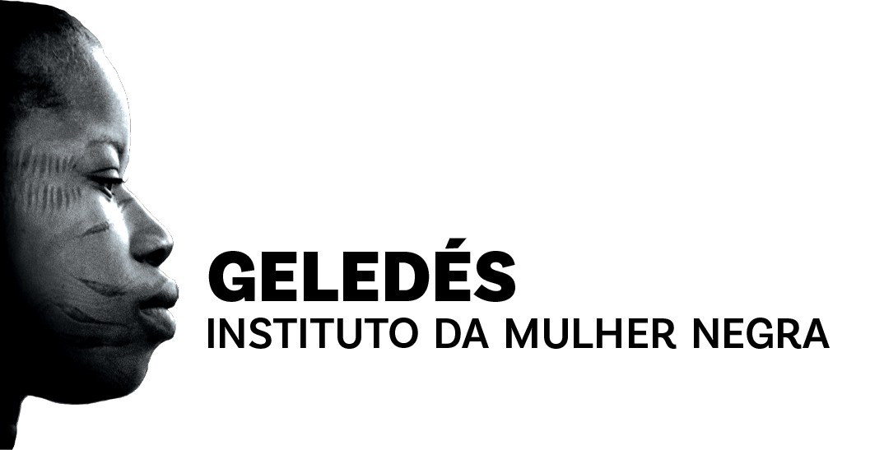

**Geledés – Black Woman Institute: Response to the Call for Contributions for FfD4**

**Introduction**

The intersection of race and gender continues to disproportionately affect women of African descent and other historically marginalized groups worldwide. Racism, as a system of oppression, impacts not only people of African descent, who sum up to 300 million people around the globe, but also racialized immigrants, religious minorities, and other vulnerable populations. These groups face power structures that dehumanize and marginalize them, with effects ranging from economic exploitation to the lack of representation in decision-making spheres.

In the context of financing for development, these inequalities are exacerbated by the unequal distribution of resources, which often lacks specific criteria addressing race and gender. The failure to acknowledge these disparities perpetuates the marginalization of these communities.

Systemic reforms in global financing mechanisms are crucial to address inequalities and promote social justice, racial and gender inclusion, and equitable economic development. The focus should not only be to address existing problems but also to rethink the structures that have historically favored a few at the expense of many.

**I. Global Financing Framework: Integrating Gender and Race into Sustainable Development, Especially in Infrastructure Projects**

It is imperative that multilateral and national development banks, which play a critical role in financing large infrastructure projects, explicitly integrate gender and race criteria into their financing structures. These criteria should be non-negotiable and central conditions to receive funding.

Infrastructure financing must take into account its impact on vulnerable territories, where the population is predominantly of African descent. These projects cannot continue to marginalize these communities in the name of development.

The criteria must ensure that multilateral and national development banks, along with commercial banks (where applicable), evaluate the economic, social, and environmental impacts on communities of African descent. They must ensure that large-scale financing does not perpetuate the structural inequalities that have long excluded these communities from economic and social benefits. For women of African descent, these barriers are even more significant due to the intersection of racial and gender discrimination. Infrastructure projects, such as road construction, hydroelectric plants, or economic development zones, often result in the displacement of communities, negatively affecting access to natural resources and land.

A clear example of this is the environmental disasters in Mariana (2015) and Brumadinho (2019), both in Minas Gerais, Brazil. In Mariana, the collapse of Samarco's dam resulted in one of the largest environmental disasters in the country’s history, destroying communities along the Doce River, many of which were quilombola (Afro-Brazilian) communities. These populations, dependent on the river for subsistence, were displaced, lost their lands and livelihoods, and still struggle to obtain adequate reparations. This is a clear example of how environmental racism disproportionately affects communities of African descent and other marginalized populations.

Similarly, the collapse of the Vale dam in Brumadinho killed more than 270 people and destroyed much of the local environment, directly affecting rural communities of African descent. While these disasters had widespread impact, it is important to note that communities of African descent and Indigenous communities were the most vulnerable, not only due to their geographical proximity but also because of the lack of protection and adequate support from the state.

Additionally, examples of mining projects in Latin America, such as those in Colombia’s Pacific region, show a pattern of forced displacement of communities of African descent due to resource extraction. In Colombia, many of these communities were expelled from their lands without fair compensation or prior consultation, as required by international human rights standards.

The incorporation of environmental racism issues is mandatory. The concept of environmental racism must be central to discussions about sustainable development. Climate change disproportionately affects communities of African descent and Indigenous populations in rural and urban areas. These populations are more vulnerable during extreme weather events, such as floods, droughts, extreme heat, and storms, and suffer greater consequences due to the lack of adaptation to climate change and protective policies. Women of African descent, in particular, face double vulnerability, as they depend on natural resources to support their families and are often marginalized in decision-making about land use and resources.

In Brazil, quilombola and other traditional communities have suffered from the expansion of agricultural and industrial projects that deforest large areas, pollute rivers, and make their lands unsuitable for agriculture and fishing. These impacts are a clear reflection of environmental racism, where the most vulnerable communities are disproportionately affected by political and economic decisions that prioritize profit over the protection of their rights and environmental preservation.

**Success Indicators:** To effectively measure the social inclusion and economic empowerment of women of African descent, it is essential to define clear indicators that reflect both living conditions and access to economic opportunities. Indicators such as average income disaggregated by race and gender, access to credit and financial services, access to essential services, and participation in leadership positions are fundamental to ensure that infrastructure and development projects truly benefit these communities. Moreover, continuous monitoring of these indicators will allow for adjustments in policies and programs, ensuring that inclusion goals are effectively achieved.

These indicators must be applied by governmental and non-governmental bodies, including statistical institutes, audit courts, multilateral agencies, and local NGOs, to ensure data impartiality and representativeness.

The FfD4 should promote:

* The explicit integration of gender and race criteria into financing structures as non-negotiable conditions for receiving funding.
* Infrastructure financing that takes into account the impact on vulnerable territories, particularly those predominantly inhabited by people of African descent.
* Criteria that ensure multilateral, national development banks, and commercial banks evaluate the economic, social, and environmental impacts on communities of African descent to avoid perpetuating structural inequalities.
* The inclusion of environmental racism issues as central to discussions on sustainable development, ensuring that infrastructure projects do not disproportionately harm marginalized communities.

**II. Reform of the International Financial Architecture**

The international financial architecture must undergo a profound reform to address the demands and challenges of developing economies, especially those facing structural inequalities related to race and gender. The current system favors wealthier countries and multinational corporations, leaving emerging economies and their most vulnerable populations at disadvantage. In this sense, mechanisms such as the UN Tax Convention must be strengthened, which can bring more balance to the way global fiscal resources are distributed.

The UN Tax Convention should be reinforced to overcome the limitations of the current OECD BEPS project, which, despite its advances with the two pillars (taxation on digital transactions and minimum taxation of multinationals), still does not adequately address the challenges faced by developing countries. Brazil, during its G20 presidency, proposed a third pillar, which seeks to ensure that emerging economies can more effectively tax multinational corporations operating in their territories.

Furthermore, the proposal for a global tax on the super-rich, as suggested by Gabriel Zucman, should be a central part of this reform. Taxing billionaire fortunes at a global rate of 2% could generate significant resources to tackle global inequalities, finance climate change mitigation and adaptation policies, and promote sustainable development in marginalized communities. This tax could be channeled to inclusive social and infrastructure projects in historically neglected regions, such as rural areas inhabited by people of African descent.

Tax evasion and avoidance remain major challenges, especially for developing countries that rely on these resources to invest in infrastructure and social policies. Without a financial architecture that levels the playing field, these countries will continue to lose billions of dollars annually, weakening their ability to promote social justice and reduce inequalities.

**Fiscal justice** is a central pillar for ensuring that resources are distributed equitably. Tax evasion and avoidance directly harm women of African descent and marginalized communities. By allowing corporations and high-income individuals to avoid paying taxes, these practices perpetuate global inequality, limiting the resources needed to fund inclusive policies.

The FfD4 should promote:

* Strengthening mechanisms such as the UN Tax Convention to bring more balance to the distribution of global fiscal resources.
* Reinforcing the UN Tax Convention to overcome the limitations of the current OECD BEPS project, ensuring that emerging economies can more effectively tax multinational corporations operating in their territories.
* The inclusion of a global tax on the super-rich, as suggested by Gabriel Zucman, as a central part of the reform, with a 2% tax on billionaire fortunes to generate resources for global inequalities, climate change mitigation, and sustainable development in marginalized communities.
* Progressive fiscal policies that ensure the wealthiest individuals and large corporations pay their fair share of taxes.
* Tax incentives for inclusive projects that promote racial and gender equity, directly contributing to reducing inequalities.

**III. Corporate Due Diligence and Human Rights**

Corporate due diligence is an essential tool to ensure that infrastructure projects financed by development banks or private investments respect human rights, particularly the rights of vulnerable populations. This includes conducting impact assessments that consider the rights of people of African descent, particularly women.

Corporations operating in sectors such as mining, energy, construction, and agribusiness have a fundamental responsibility to ensure that their operations do not harm these communities. A lack of due diligence can lead to human rights violations, such as forced population displacement, environmental pollution, and labor exploitation.

As previously mentioned, in mining projects in Latin America, communities of African descent have been systematically displaced without adequate compensation, losing their lands and livelihoods. This reinforces the need to include continuous monitoring mechanisms and robust impact assessments to ensure that these corporations are held accountable for their impacts.

The FfD4 should promote:

* Mandatory corporate due diligence in infrastructure projects to ensure that they respect human rights and do not harm marginalized communities.
* Continuous monitoring mechanisms and robust impact assessments to ensure corporations are held accountable for their impacts, particularly in sectors like mining, energy, construction, and agribusiness.

**IV. Economic Empowerment of People of African Descent**

Taking Brazil as an example, one notes that the country has a history of wealth-building policies based on subsidies that disproportionately benefited European immigrants, particularly during the post-abolition period. This also is the case of several other countries. Incentive programs that privileged these groups, while the newly freed population of African descent was systematically excluded from economic and social opportunities, perpetuated structural inequalities that persist today. One example is the 2023/2024 Agricultural Plan, which allocated R$ 360 billion to agricultural credit, more than double the Bolsa Família budget. Of the total, 70% went to soybean and corn exports, essentially led by white individuals, while family farming received only 1%.

In this sense, the economic empowerment of women of African descent is not only a matter of social justice but also an essential strategy for inclusive and sustainable economic growth. In many countries, women of African descent are on the margins of the formal economic system, with limited access to credit, education, and financial resources. This limits their opportunities for personal and community development.

Creating microcredit programs targeted at women of African descent, along with providing financial and technical training, is a practical solution to overcome these barriers. Additionally, these programs must be integrated into affirmative action policies, ensuring that women of African descent are prioritized in access to economic and business opportunities.

Multilateral and national development banks should be encouraged to adopt these initiatives in their financing programs, promoting the development of small and medium-sized businesses led by women of African descent. These initiatives should be accompanied by awareness campaigns and business training, fostering a culture of inclusion and opportunities for marginalized groups.

The FfD4 should promote:

* Microcredit programs targeted at women of African descent, along with providing financial and technical training to overcome barriers to economic inclusion.
* Affirmative action policies that prioritize women of African descent in access to economic and business opportunities, ensuring their inclusion in development financing.

**V. Technology, Innovation, and Digital Inclusion**

The UN Working Group of Experts on People of African Descent has emphasized the urgent need to integrate digital inclusion policies that address the inequalities faced by communities of African descent, particularly women. In its latest session, the group highlighted that while digitalization is a powerful force for economic growth, it can also exacerbate existing racial inequalities if these communities continue to be excluded from technological advances.

The absence of specific policies for digital inclusion can aggravate structural inequalities and perpetuate cycles of poverty. In this sense, the inclusion of African descent communities in digital programs and their access to information and communication technologies (ICT) must be prioritized in the FfD4 discussions.

There is a direct connection between racial exclusion and limited access to technology. A World Bank report indicates that access to the internet, mobile phones, and other ICTs is essential for economic and social development, particularly in underserved regions​​. However, in many developing countries, communities of African descent, especially in rural and peri-urban areas, have limited or no access to these technologies, creating a digital divide that further marginalizes them. Women of African descent are particularly affected by this divide, as they often have less access to education and training in technology.

Thus, it is crucial to develop targeted programs for technological and digital literacy, fostering the inclusion of women of African descent in the digital economy. Public policies should promote the development of entrepreneurial and innovative skills among these women, enabling them to actively participate in the global digital economy. This can be achieved through partnerships with multilateral organizations, national governments, and the private sector, which can provide the necessary resources and training to support these communities.

Furthermore, policies should be implemented to combat algorithmic racism, a form of structural discrimination that manifests itself in the programming of algorithms, reinforcing existing inequalities. Artificial intelligence systems, widely used in areas such as employment, social benefits, and criminal justice, can perpetuate racial biases if not developed and monitored carefully. To combat this, it is necessary to develop guidelines and regulatory frameworks that ensure transparency, accountability, and ethical standards in the use of algorithms and AI, preventing racial discrimination and promoting justice.

The FfD4 should promote:

* Targeted programs for digital and technological inclusion to bridge the digital divide faced by communities of African descent, particularly women.
* Policies that combat algorithmic racism and promote transparency, accountability, and ethical standards in the use of AI and algorithms, ensuring racial justice in technological advancements.

**Conclusion**

The inclusion of race and gender criteria in global financial systems is crucial to addressing structural inequalities that disproportionately affect people of African descent and marginalized communities. Reforming financing mechanisms to prioritize racial justice, poverty reduction, and social inclusion is essential for truly sustainable and equitable global development.

FfD4 represents an opportunity to align financial policies and practices with the goals of justice and equality. It is imperative that these reforms go beyond surface-level changes and address the root causes of inequality, ensuring that people of African descent and other historically marginalized communities are central to global development efforts.