## **Financing Policy Brief Series – Recommendations for FfD4**

## **Accelerating the mobilization of domestic and international private finance towards the Sustainable Development Goals**

Prepared by the Economic and Social Commission of Asia and the Pacific (ESCAP)

Bangkok, Thailand

18 October 2024

## **Key messages (max. 200 words)**

* Strengthen financial regulations to facilitate and accelerate private financing towards the Sustainable Development Goals. Regulators should also strive for greater consistency with regional and global sustainable finance taxonomies and roadmaps. This would ensure that international investors can benefit from interoperability and provide incentives for foreign capital.
* Undertake actions to develop and deepen domestic banking and capital markets and ensure that sustainability considerations are fully embedded.
* Ensure that more concessional and private finance flow towards the least developed countries (LDCs), as well as more challenging sectors and projects. For the LDCs as well as countries with low sovereign credit ratings, concessional finance by multilateral development banks and development finance institutions can act as an effective de-risking mechanism for private finance, if undertaken in partnership with the government and the private sector.
* Enhance strategic foreign direct investment (FDI) promotion to accelerate Sustainable Development Goal-aligned investments. Although FDI plays a crucial role in financing sustainable development, a significant gap remains in channeling these investments towards Sustainable Development Goal priorities in Asia-Pacific countries.

## **Problem statement (500 words)**

To effectively mobilize private finance in support of the Sustainable Development Goals, a transformation of the national, regional and international financial architecture is required. In addition to actions needed by regulators and policymakers at the national level, such a transformation would also need a change in the approaches of multilateral concessional finance providers, such as the multilateral development banks. They need to work closely with private finance entities to de-risk investments, especially in LDCs and in more challenging sectors and projects. On their part, private businesses need to step up and implement their voluntary sustainability-related commitments. Many have already transformed their supply chains to become more sustainable, divested assets, ceased some activities that do harm, and are designing future business plans, such as transition plans, that chart a progressively more sustainable path. But much more needs to be done.

***Key challenges hampering mobilization of domestic and international private finance***

The first main challenge is the underdeveloped and highly disparate state of capital markets in most Asia-Pacific economies. Key features of this include: weak state of market infrastructure as reflected in underdeveloped exchanges of stocks, securities, derivatives and other financial instruments; weak clearing systems to settle financial trades; absence of guiding frameworks to issue different financial instruments; absence of bondholder rights and insolvency regulations; lack of secondary markets particularly for corporate bonds; and regulations that hinder foreign ownership or produces taxation issues.[1]

Two, the institutional investor base, such as pension funds or insurance companies which can provide stability and liquidity, is small compared to Organization for Economic Co-operation and Development (OECD) countries. Domestic savings are still primarily channeled through banks rather than capital markets for the majority of countries in the region.

Three, corporate governance remains a binding constraint in many capital markets because of the poor quality of financial reporting by domestic businesses and weaknesses in the legal system that makes it difficult for investors to seek redress in courts, if needed.

Four, the enterprise landscape in Asia and the Pacific is dominated by micro, small and medium enterprises (MSMEs).[2] Such enterprises are predominantly funded by internal funding (equity). Sometimes they borrow from formal channels such as banks, however, they primarily do not raise capital through securities in the capital markets.

Five, less than desirable policy coherence and coordination in terms of national priorities and planning, related to the Sustainable Development Goals, between different ministries, departments and agencies remain an issue in several economies. This creates uncertainty, imposes significant transaction costs on private finance, and reduces the financial efficiency of sustainable finance, bringing down returns and making private investments in support of Sustainable Development Goals less desirable.

***Need for integrated actions by regulators and policymakers***

Addressing these challenges and ensuring that private finance flows at scale towards the Sustainable Development Goals would require a suite of integrated actions by policymakers and regulators. Such actions encompass the developing and deepening financial markets and strengthening sustainable finance (figure 1). Examples of key actions include implementation of sustainability-focused financial risk management approaches, promotion of sustainable financial product development (such as sustainable bonds), and adoption of sustainable taxonomies and disclosure frameworks underpinned by a sustainable finance roadmap. Clear, coherent and integrated actions by banking and capital market regulators along these lines can signal stability and predictability to investors, enabling long-term investments.

**Figure 1. Financial sector development and sustainable finance actions**

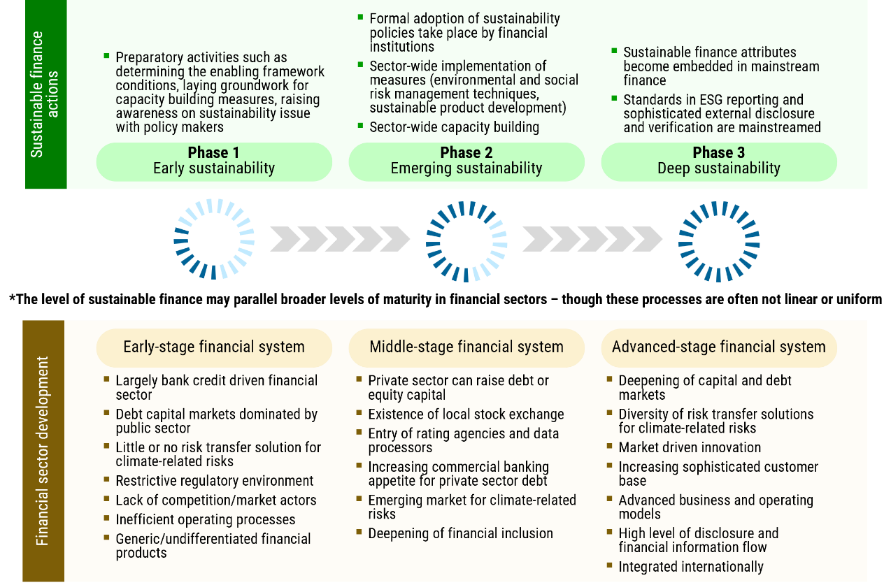

*Source:* ESCAP and Global Green Growth Institute, “ASEAN Green Map”, paper prepared for the Association of Southeast Asian Nations, Jakarta, forthcoming.

## **Policy solutions (500 words)**

1. **Strengthen financial regulations that accelerate private financing towards the Sustainable Development Goals, in line with national circumstances**. Changes in financial regulations that prioritize sustainability considerations will influence the behavior of businesses operating in different sectors of the economy. For this, regulators will need to invest in data and capacities of their staff and systems to design, monitor and enforce effective sustainable financing regulations. Moreover, regulators should also strive for greater consistency with regional and global sustainable finance taxonomies and roadmaps. This would ensure that international investors can benefit from interoperability and provide incentives for foreign capital to flow towards the Sustainable Development Goals.
2. **Undertake actions to develop and deepen domestic banking and capital markets and ensure that sustainability considerations are further embedded.** Examples of potential actions include: efforts to increase the institutional investor base; strengthening of corporate governance; development of more efficient banking and capital market infrastructure; sufficient technical capacity and knowledge provided to market intermediaries; implementation of robust regulatory and supervisory frameworks with strengthened investor protection policies; ensuring adequate and independent credit risk assessment for companies of all sizes; and improving secondary market liquidity.
3. **Ensure that more concessional and private finance flow towards the LDCs, as well as more challenging sectors and projects.** For the LDCs as well as countries with low sovereign credit ratings, concessional finance by multilateral development banks and development finance institutions can act as an effective de-risking mechanism for private finance, if undertaken in partnership with the government and the private sector. Setting up a modality in which the private sector (project developers) and financial institutions regularly meet and co-create sustainable projects in a progressive and iterative manner can accelerate the preparation of effective pipelines of sustainable projects at scale. Doing so would require a change in mindset of both the concessional and private finance providers operating in LDCs.
4. **Enhance promotion of Foreign Direct Investment (FDI) to accelerate Sustainable Development Goal-aligned investments.** FDI plays a crucial role in financing sustainable development, yet a significant gap remains in channeling these investments towards Sustainable Development Goal priorities in Asia-Pacific countries. Key considerations include developing sector-specific expertise within investment promotion agencies (IPAs); improving coordination between IPAs and policymakers; leveraging digital technologies for better investor targeting; and exploring innovative policy instruments to attract Sustainable Development Goal-aligned FDI. By refocusing FDI promotion efforts on sustainable development priorities, countries can more effectively leverage international private finance to address pressing development challenges and accelerate progress towards the Sustainable Development Goals, while balancing the quantity and quality of incoming investments.

## **Specific recommendations for FFD4 (300 words)**

* Ensure that the Elements Paper and draft Outcome Document reflects urgency towards a whole-of-government approach on strengthening the coherence of financial regulations by banking and capital markets regulators and policies from national policymakers and aligning them with the Sustainable Development Goals.
* Ensure that financial deepening of domestic banking and capital markets is reflected as a prerequisite to ensuring more private finance towards the Sustainable Development Goals.
* Ensure that the draft Outcome Document reflects a differentiated approach towards catalysing both concessional and private finance in the LDCs and calls for public and private stakeholders to reform their partnership approach to financing the Sustainable Development Goals in these countries.

**A 75-word summary of the brief for the website.**

This brief focuses on the importance of strengthening financial regulations that can accelerate private financing towards the Sustainable Development Goals in the Asia-Pacific region. The brief puts forward actions to deepen banking and capital markets in Asia and the Pacific, as well as outlines a new approach that combines concessional and private finance in the least developed countries in Asia and the Pacific.

1. OECD, *Corporate Bond Markets in Asia: Challenges and Opportunities for Growth Companies* (Paris, OECD Publishing, 2024).
2. Asian Development Bank, *Asia Small and Medium-sized Enterprise Monitor 2023: How Small Firms Can Contribute to Resilient Growth in the Pacific Post COVID-19 Pandemic* (Manila, 2023).