## **Financing Policy Brief Series – Recommendations for FfD4**

## **Financing Development through Trade: Harnessing Digital Opportunities**

Prepared by the Economic and Social Commission of Asia and the Pacific (ESCAP)

Bangkok, Thailand

21 October 2024

## **Key messages (max. 200 words)**

* Digital trade offers new financing opportunities, including e-commerce, digitally delivered services, and innovative financial models like blockchain and crowdfunding. However, these opportunities remain unevenly distributed in Asia and the Pacific.
* A significant challenge is the digital divide, where high-income countries benefit from robust infrastructure, while LDCs face inadequate connectivity and limited digital infrastructure.
* Additionally, inconsistent regulatory frameworks impede cross-border digital trade, creating barriers for many economies. Compounding these challenges are labor shortages and gender disparities, which limit access to digital skills and tools, as only a small percentage of Micro, Small and Medium-sized Enterprises (MSMEs) use advanced digital platforms, further restricting their ability to fully leverage digital trade opportunities and drive inclusive economic growth.
* Policies focused on closing the digital divide in LDCs, establishing global digital tax frameworks, promoting capacity building, and strengthening regulatory cooperation can help address these challenges.

## **Problem statement (max. 500 words)**

As global trade increasingly shifts toward digital platforms, new financing opportunities are emerging—including trade through e-commerce, digitally delivered services, and innovative financial models like blockchain and crowdfunding. However, according to the *Asia-Pacific Trade and Investment Report (APTIR) 2023* by United Nations ESCAP, UNCTAD, and UNIDO, these opportunities remain unevenly distributed. While the region’s digitally deliverable services accounted for 52 per cent of its total services exports, six economies dominate 85 per cent of them. Conversely, the twelve Asia-Pacific least developed countries (LDCs) represent less than 1 per cent of the region's digital exports, mainly due to skill gaps, regulatory hurdles, and infrastructure deficiencies. Additionally, only 0.10 per cent of digital foreign direct investment (FDI)( flowed to the LDCs, underlining persistent inequalities in access to digital trade and investment opportunities (figure 1).

**Figure 1. Cumulative FDI values per Asia-Pacific LDCs over the 2017 - 2022 period**

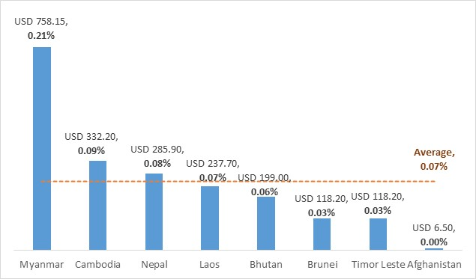

Source: ESCAP-UNCTAD-UNIDO (2023). Asia-Pacific Trade and Investment Report 2023/2034: Unleashing Digital Trade and Investment for Sustainable Development. <https://www.unescap.org/kp/APTIR2023>

One of the primary barriers to fully leveraging digital trade for development financing is the digital divide. High-income countries enjoy the benefits of advanced digital infrastructure and widespread internet access, whereas LDCs struggle with inadequate connectivity. ESCAP research shows that a 1 per cent increase in digital trade value is associated with a 0.8 per cent rise in real GDP per capita growth. However, these benefits are not reaching countries with special needs—such as LDCs, Landlocked Developing Countries (LLDCs), and Small Island Developing States (SIDS)—due to their infrastructure and policy gaps.

Further exacerbating the issue, regulatory frameworks across the region are inconsistent and incomplete, hindering the potential for cross-border digital trade. For example, while paperless trade can reduce costs, the Asia-Pacific region’s cross-border paperless trade implementation is slow, with an implementation rate of only 42 per cent in 2023 (figure 2). Laws concerning data protection and consumer protection are also fragmented across countries, creating hurdles for businesses, particularly MSMEs. The lack of standardized data-sharing protocols and complex cybersecurity regulations makes it harder for MSMEs to compete, and most digital service exports remain concentrated in a few advanced economies.

**Figure 2. Asia-Pacific implementation rate of trade facilitation measures**

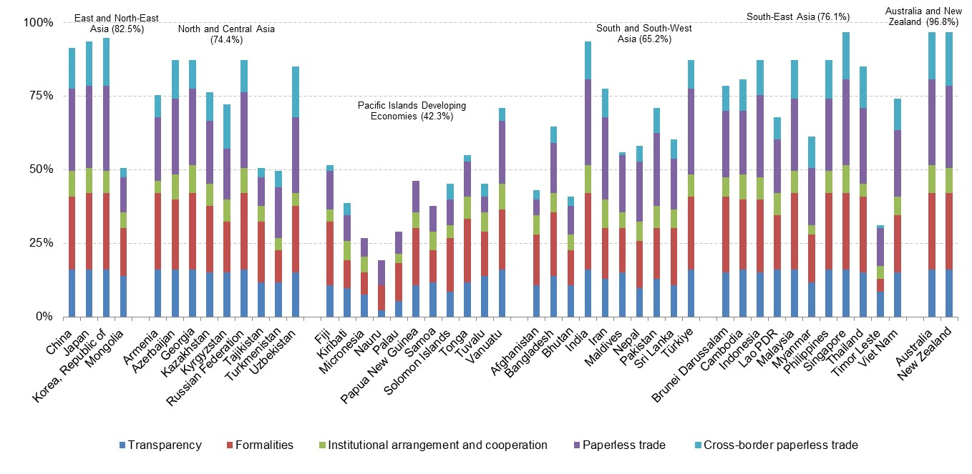

Source: ESCAP-UNCTAD-UNIDO (2023). Asia-Pacific Trade and Investment Report 2023/2034: Unleashing Digital Trade and Investment for Sustainable Development. <https://www.unescap.org/kp/APTIR2023>

Shortage of skilled digital workers further limits the growth of digital trade. In some Southeast Asian countries, 56 per cent of MSMEs rely on basic digital tools, while only 10 per cent use advanced digital platforms. Women and rural populations also face significant barriers to digital trade. For instance, female entrepreneurs in South-East Asia often lag behind in education and digital skills compared to their male counterparts, with a 14 per cent gender gap in digital payments in Bangladesh.

Finally, as the region considers changes to digital trade taxes—such as phasing out the Moratorium on Customs Duties on Electronic Transmissions and reducing De Minimis Thresholds—there is concern about the impact on MSMEs and informal digital workers. These measures could increase operational costs for businesses that are already struggling with regulatory challenges. Without well-considered policy interventions, these developments may stifle growth and reduce the potential for digital trade to serve as a significant source of financing for development

## **Policy solutions (max. 500 words)**

To fully capitalize on digital trade for financing development in the Asia-Pacific region, an integrated policy framework is necessary.

First, expanding digital infrastructure in LDCs, Landlocked Developing Countries (LLDCs), and Small Island Developing States (SIDS) is essential to address connectivity gaps and create a foundation for broader participation in the digital economy. Investments in broadband and technological infrastructure, combined with public-private partnerships, can ensure that underserved regions are better equipped to engage in digital trade.

Second, the development of digital skills must be a top priority, particularly for Micro, Small, and Medium-sized Enterprises (MSMEs) and marginalized groups, such as women and rural communities. Governments should launch national-level programs to provide technical education and training in digital literacy. With only a small percentage of MSMEs using advanced digital platforms, such programs are crucial to helping smaller businesses leverage the full potential of digital trade.

Next, regulatory harmonization is key to reducing barriers in cross-border digital trade. Governments should work together to create standardized frameworks for data protection, cybersecurity, and consumer protection, while also accelerating the adoption of paperless trade systems. This will not only reduce costs but also foster trust among businesses and consumers engaging in cross-border e-commerce.

In addition, attracting foreign direct investment (FDI) into the digital economy can help foster growth in underserved regions. Establishing digital Special Economic Zones (SEZs) with fiscal incentives, as well as simplifying ownership and licensing regulations, would draw more investment into these areas. Innovative financing models like blockchain and crowdfunding should also be encouraged to provide MSMEs with alternative avenues for raising capital.

Taxation policies related to digital trade must strike a balance between generating revenue and supporting MSMEs. A sudden increase in tax obligations could hinder their growth and innovation. Instead, governments should phase in changes while offering support mechanisms, allowing smaller enterprises time to adapt and continue to thrive in the evolving digital economy. Additionally, formalizing e-commerce MSMEs and digital-economy workers through coordination with digital platforms would integrate them into the tax system, helping governments capture a broader tax base. This approach would not only improve revenue collection but also provide essential social protection to workers.

Finally, addressing gender disparities in digital trade participation is critical for inclusive growth. Governments should implement gender-specific policies that promote women’s participation in digital sectors, offering financial and technical assistance tailored to female entrepreneurs. By ensuring that women and marginalized groups are equipped with digital skills and have access to online markets, the region can foster more equitable economic growth.

## **Specific recommendations for FFD4 (max. 300 words)**

Aligning with the mandate to focus on domestic resource mobilization, international cooperation, global economic governance, and financing for development in LDCs and vulnerable countries, the recommendations could focus on:

1. Mobilizing international and domestic financing to close the digital divide in LDCs. This investment would support broader participation in digital trade, enhancing economic resilience.
2. Establishing a global framework to address the taxation of digital trade while ensuring that MSMEs are not disproportionately burdened. This would help harmonize global tax policies and secure financing for development without stifling small businesses.
3. Encouraging international cooperation and funding for capacity-building programs to enhance digital literacy and skills, especially for MSMEs, women, and marginalized groups, ensuring they can fully participate in the digital economy.
4. Strengthening regulatory collaboration through multilateral and regional frameworks to align digital trade regulations, cross-border e-commerce rules, and interoperable systems. For example, by promoting standardized paperless procedures and streamlining document exchanges between countries, the Framework Agreement on Cross-Border Paperless Trade Facilitation in Asia and the Pacific (CPTA) establishes a foundation for promoting efficient, secure, and interoperable systems, supporting cross-border e-commerce.

**A 75-word summary of the brief for the website.**

This policy brief highlights the challenges faced by Asia-Pacific developing economies, in particular LDCs, in tapping the potential of digital trade opportunities to finance sustainable development, and discusses some potential policy solutions. It focuses on promoting domestic resource mobilization, fostering international cooperation, and supporting LDCs to participate in digital trade. The key recommendations include closing the digital divide, establishing coordinated digital tax frameworks, strengthening regulatory cooperation, and building digital-trade capacity for MSMEs and marginalized groups.