Financing Policy Brief Series – Recommendations for FfD4: Closing the financing gap for universal social protection

Summary

*This brief presents evidence on coverage and financing gaps for universal social protection (USP), offering actionable recommendations for FfD4. The ILO estimates that to ensure at least a social protection floor, low- and middle-income countries require an additional investment of US$ 1.4 trillion (3.3 per cent of the aggregate GDP) of these countries. To close the financing gap countries must increase investment in social protection, raising effective coverage by 2 percentage points annually (SDG indicator 1.3.1). At the international level, debt relief should move at a faster pace and access to international emergency financing must be enhanced to enable regular investment in USP in a climate-volatile world and avoid repeated rounds of austerity.*

Key messages

* Today, 52.4 per cent of the global population is covered by some form of social protection, up from the 42.8 per cent in 2015. Despite remarkable progress, this still leaves 3.8 billion people without any protection. Under-investment in social protection continues to be one of the main reasons for low coverage rates, leaving billions of people behind.
* ILO evidence shows that financing gaps in social protection are still large. To ensure at least a social protection floor, low- and middle-income countries require an additional investment of US$ 1.4 trillion or 3.3 per cent of the aggregate GDP (2024) of these countries, including 2 per cent of GDP or US$ 833 billion for essential health care and 1.3 per cent of GDP or US$ 552 billion for five social protection cash benefits.
* To close these coverage gaps, Member States must increase regular domestic financing through social security contributions and progressive taxation, considering that building social protection systems implies long term commitments. Countries with insufficient fiscal capacities may require temporary international support in building up robust social protection systems that allow them to tackle the challenges ahead.
* The outcome document of FfD4 presents a crucial opportunity to boost the political will to invest in universal social protection (USP) and universal health coverage (UHC) and to close the financing gap. The document should specifically indicate the benefits of investing in social protection, in terms of poverty and inequality reduction, as well as GDP growth within planetary boundaries.
* In the FfD4 outcome document Members States should commit to close the financing gap by raising social protection spending to increase effective coverage in countries where social protection is not universal. Such an increase, measured by SDG indicator 1.3.1, should be at least 2 percentage points annually. At the same time, the International Financial Institutions should commit to increasing the pace of debt relief for countries in distress and providing emergency financing for countries facing macroeconomic and other crises, for example, by making better use of IMF’s SDR issuing authority.

## **Problem statement: In 2024, there is still a social protection financing gap of 3.3 per cent of GDP equaling 1.4 trillion USD**

Social protection is defined as the set of policies and programmes designed to reduce and prevent poverty, vulnerability and social exclusion throughout the life cycle. It includes nine main areas: child and family benefits, maternity protection, unemployment support, employment injury benefits, sickness benefits, health protection (medical care), old-age benefits, invalidity/disability benefits, and survivors’ benefits. Social protection systems address all these policy areas by a mix of contributory schemes (social insurance) and non-contributory tax-financed benefits (including social assistance).

As a human right, social protection, or social security, is enshrined in the Universal Declaration of Human Rights (1948), the International Covenant on Economic, Social and Cultural Rights (1966), and other major United Nations human rights instruments, and is guided by international social security standards. States have a legal obligation to protect and promote human rights, including the right to social protection, and to ensure that people can realize their rights without discrimination. The State bears the overall responsibility for putting in place universal social protection systems.

Today, 52.4 per cent of the global population is covered by some form of social protection, up from the 42.8 per cent in 2015. However, 47.6 per cent of the global population, about 3.8 billion people, are not currently covered by any social protection scheme.[1] This coverage gap exposes billions of people to existential risks and thwarts sustainable development. Evidence shows that higher expenditure on social protection is associated with lower income inequality and poverty.[2] Under-investment in social protection continues to be one of the main reasons for the low coverage rates. Public expenditure on social protection (excluding healthcare) was, on average, 12.9 per cent of GDP worldwide (in 2023) and expenditure on health was 6.5 per cent of GDP (Figure 1). In Africa, expenditure reaches only 3.7 and 2.1 per cent of GDP respectively, leaving significant protection gaps that thwart economic and social development.[3]

**Figure 1. Public social protection expenditure, 2023 or latest available year, domestic general government health expenditure, 2021, by region, subregion and income level (percentage of GDP)**

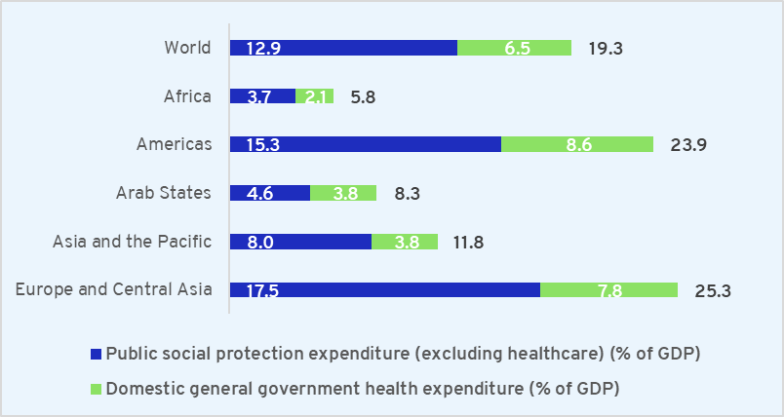

Source: ILO, 2024. World Social Protection Report 2024–26.

Financing gaps in social protection are still large. To ensure at least a social protection floor, low- and middle-income countries require an additional investment of US$ 1.4 trillion or 3.3 per cent of the aggregate GDP (2024) of these countries, including 2.0 per cent of GDP or US$ 833 billion for essential health care and 1.3 per cent of GDP or US$ 552 billion for five social protection cash benefits (Figure 2).[4] This represents an average increase in social protection expenditure of 10.6 per cent of the existing government expenditure in low- and middle-income countries. Such investment will ensure universal coverage of basic benefits to all children, mothers of newborns, persons with severe disabilities, the unemployed, and older persons, as well as universal essential health care. At a more disaggregated level, in Africa, for example, the financing gap is considerable, amounting to 17.6 per cent of the regional GDP and 306.2 per cent of current government expenditure. This shows that closing the financing gap is not possible without a massive sea-change in the domestic resource mobilization efforts of countries and in the international financial architecture to ensure its alignment with the principle of global solidarity.

**Figure 2. Financing gap for achieving universal social protection coverage per year, as a percentage of GDP, by social protection benefit, by national income group, and by region, 2024**

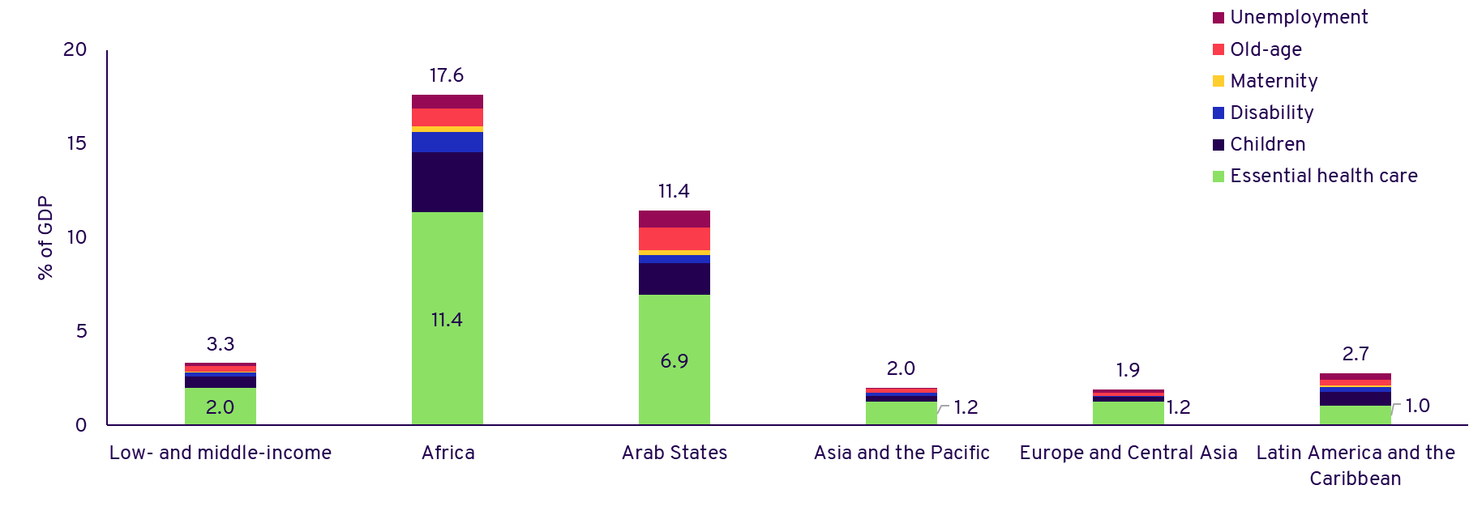

Source: Cattaneo, U., Schwarzer, H., Razavi, S., Visentin, A. 2024. Financing gap for universal social protection: Global, regional and national estimates and strategies for creating fiscal space, ILO Working Paper 113 (Geneva, ILO).

Policy solutions: Expand the fiscal space for social protection

***Domestic resource mobilization***

The ILO financing gap estimations show that to deliver on the agreed goals of universal social protection (USP) under SDG target 1.3 and universal health coverage (UHC) under target 3.8, Member States must increase regular domestic financing, considering that building both health and social protection systems implies long term commitments. Priority should be given to building social protection floors that can guarantee at least a basic level of protection.

At the national level, this involves ensuring a broad tax base with progressive taxation and social security contribution levels from employers and workers, which in turn also supports the formalization of enterprises and employment. In most countries, social security contributions are proportional to earnings and, thus, provide the necessary income-smoothing mechanisms. However, certain workers do not have sufficient contributory capacity and therefore need to rely on non-contributory (usually tax-financed) social protection benefits and/or contribution subsidies. For this reason, it is of paramount importance to complement social security contributions with progressive taxation, including progressive taxes on income and profits, as well as wealth taxes rather than over-reliance on largely regressive consumption taxes. Such sources of government finance are usually managed by ministries of finance, therefore it is crucial to facilitate their engagement with ministries of labour, as well as with workers and employers’ organizations, in order to enhance policy coherence in the formulation of financing strategies for social protection.

In the context of the climate crisis, reallocating some public expenditures, such as fossil fuel subsidies, is of utmost importance to both mitigate a warming planet and expand domestic financing of social protection.[5] Such reforms can support increasing expenditure for non-contributory social protection benefits, eliminating or reducing user fees for health care services or subsidizing the extension of social insurance coverage for those with low contributory capacity, thereby facilitating transitions of enterprises and workers from the informal to the formal economy. Furthermore, at the domestic level, eliminating illicit financial flows, including money laundering, tax evasion, trade mispricing, and other financial crimes, is essential to generate additional fiscal space for social protection and health systems.

***International financial architecture and international support for social protection in low-income countries***

At the global level, there is a need to level the playing field in terms of corporate taxation by bringing an end to the race to the bottom of tax concessions to corporations, which have only resulted in lower tax proceedings.[6] Furthermore, governments lose a large amount of tax revenue due to tax evasion and tax avoidance, such as through the practice of shifting firms’ profits to low-tax jurisdictions or tax havens, as well as trade mispricing. In many developing countries, the lost tax revenue from such practices is more than enough to close the social protection financing gap.[7] Therefore, it is imperative to scale-up efforts to measure and combat illicit financial flows.

For African countries, international solidarity is crucial to support their efforts, given their significant financing gap 17.6.[8] In many of these countries, Official Development Assistance (ODA) should kick-start and support efforts to strengthen the delivery of social protection and healthcare benefits, which in turn contributes to enhanced productivity and inclusive growth, thereby broadening the tax base and expanding government revenues.

Although government borrowing is not a sustainable solution for closing the financing gap, the effective management of sovereign debt can unlock additional resources to allocate to social protection and health spending. In 2022, 3.3 billion people lived in 48 countries where interest payment on debt was greater than investment in education and/or healthcare.[9] However, there is a need to reform debt restructuring mechanisms, as the current frameworks for debt treatments have been often slow and insufficient, especially when dealing with both external and domestic debts. Finally, access to international emergency financing is equally critical for countries facing macroeconomic shocks and other crises, be they epidemics or climate-related disasters. This will enable regular investment in USP and UHC in a climate-volatile world, rather than having to succumb to repeated rounds of austerity which erode the reach and adequacy of social protection and public services to the detriment of people and the planet.

Specific recommendations for FfD4

The outcome document of FfD4 should contain:

1. **A commitment from Member States to increase financing for USP and UHC which generates considerable benefits in terms of poverty and inequality reduction, as well as GDP growth through its multiplier effects**.[10] Such commitment requires political will to ensure a sustainable and stable financing of social protection and health systems, thereby ensuring the closure of the existing large gaps in terms of coverage and adequacy of benefits. This is in line with the Social Protection Floors Recommendation, 2012 (No. 202), which calls for at least basic income security and access to essential healthcare for everyone as a key step to realize the human right to social security as enshrined in the Universal Declaration of Human Rights (1948).
2. **Domestic resource mobilization is the main avenue for financing social protection, considering that building both health and social protection systems implies long term commitments.** Priority should be given to building social protection floors that can guarantee at least a basic level of protection.
3. **The text should further specify that international solidarity is of utmost importance for countries where financing gaps are significant.** The management of sovereign debt is crucial when there is room to reduce the cost of debt service and re-allocate the savings to social protection and health. Access to international emergency financing is equally critical in the face of macroeconomic shocks and crises to enable countries to regularly invest in USP and UHC in a climate-volatile world, rather than succumb to repeated rounds of austerity.
4. **A quantitative target on social protection coverage is preferable to one on expenditure, as not all expenditure on social protection leads to an increase in social protection coverage**. In countries where social protection is not yet universal, Member States should commit to raising social protection spending to increase effective coverage (SDG indicator 1.3.1) by 2 percentage points annually. This level of ambition is close to the annual increase in social protection coverage observed in upper-middle-income countries between 2015 and 2023 (1.8 pp/year).[11] The text should further stress that countries need to enhance the adequacy of benefits, guided by international social security standards, and strive for higher standards of income security and healthcare access for as many people as possible, as quickly as possible.
5. Finally, **International Financial institutions should also commit to increasing the pace of debt relief for countries in debt distress.** They should also provide emergency financing for countries facing macroeconomic and other crises, for example, by making better use of IMF’s SDR issuing authority.

1. ILO, ‘[World Social Protection Report 2024-26: Universal Social Protection for Climate Action and a Just Transition’](https://www.ilo.org/media/593496/download), 2024.
2. Razavi S., Cattaneo U., Schwarzer H. and Visentin A., 2024 forthcoming. “Combatting Inequalities: What Role for Universal Social Protection?”
3. ILO, ‘[World Social Protection Report 2024-26: Universal Social Protection for Climate Action and a Just Transition’](https://www.ilo.org/media/593496/download), 2024.
4. The five cash benefits are: basic benefits to all children, mothers of newborns, persons with severe disabilities, the unemployed, and older persons Cattaneo, U., Schwarzer, H., Razavi, S., Visentin, A. 2024. [Financing gap for universal social protection: Global, regional and national estimates and strategies for creating fiscal space](https://www.ilo.org/publications/financing-gap-universal-social-protection-global-regional-and-national), ILO Working Paper 113 (Geneva, ILO).
5. ILO, ‘[World Social Protection Report 2024-26: Universal Social Protection for Climate Action and a Just Transition’](https://www.ilo.org/media/593496/download), 2024.
6. ILO, ISSA, OECD 2023. [Sustainable financing of social protection. Technical paper prepared for the 1st meeting of the G20 Employment Working Group under the Indian presidency](https://www.ilo.org/publications/sustainable-financing-social-protection); ILO. 2019. Fiscal space for social protection. A handbook for assessing financing options.
7. ILO, 2019. Fiscal Space for Social Protection. A Handbook for Assessing Financing Options.
8. Cattaneo, U., Schwarzer, H., Razavi, S., Visentin, A. 2024. [Financing gap for universal social protection: Global, regional and national estimates and strategies for creating fiscal space](https://www.ilo.org/publications/financing-gap-universal-social-protection-global-regional-and-national), ILO Working Paper 113 (Geneva, ILO).
9. GCRG (United Nations Global Crisis Response Group on Food, Energy and Finance). 2022. “Global Impact of the War in Ukraine: Billions of People Face the Greatest Cost-of-Living Crisis in a Generation.” Briefing 2. New York: United Nations.
10. Cardoso, Dante, Laura Carvalho, Gilberto Tadeu Lima, Luiza Nassif-Pires, Fernando Rugitsky, and Marina Sanches. 2023. ‘[The Multiplier Effects of Government Expenditures on Social Protection: A Multi-Country Analysis](https://socialprotection-pfm.org/wp-content/uploads/2023/11/wp18_multiplier-multi-country.pdf)’. Department of Economics - FEA/USP, Working Paper Series.
11. ILO, ‘[World Social Protection Report 2024-26: Universal Social Protection for Climate Action and a Just Transition’](https://www.ilo.org/media/593496/download), 2024.