# Financing Policy Brief Series – Recommendations for FfD4

# Building tax capacity and raising additional revenue for development and growth (IMF)

## Key messages

* **Building tax capacity**—the policy, institutions, and technical capabilities to collect tax revenue—is central to the role of government in development.
* Tax capacity is also integral to achieving the **Sustainable Development Goals (SDGs)**, addressing climate change, and ensuring debt sustainability.
* Despite progress in revenue collection, there is a **large unmet tax potential in developing countries**.
* Developing countries can raise their tax-to-GDP ratio by, on average, 6.7 percentage points to achieve their full potential, given current institutions and economic structures. Institutional reform, by bringing them to the level of emerging market economies can raise an additional 2.3 points—a combined potential of 9 percent of GDP.
* This revenue increase requires **strengthening the design of core taxes**—VAT and excises and personal and corporate income taxes. **Improvement in institutions** that govern the tax system and manage tax reform is key to yielding results.
* Tax capacity must continue to rest primarily on improving the design and administration of the core domestic taxes. Ongoing **international cooperation** on the taxation of the profits of multinational enterprises (MNEs), though important, is insufficient to meet revenue mobilization needs of LIDCs and should not distract from pursuing the wider objective of building tax capacity for development.

## Problem statement

**Building tax capacity—the policy, institutions, and technical capabilities to collect tax revenue—is central to the role of government in development.** The COVID-19 pandemic, the global energy crisis, and recent wars and conflicts are reminders that economic resilience rests in no small part on domestic public revenue levers and the ability to fund suitable policy responses.

**Tax capacity is also integral to achieving the Sustainable Development Goals (SDGs), addressing climate change, and ensuring debt sustainability.** Estimates suggest that additional average annual spending of up to 16 percent of GDP is needed in low income developing countries (LIDCs) to reach the SDGs by 2030.

**Despite progress, there is a large unmet tax potential in LIDCs.** Tax revenue has progressed in LIDCs, with the average tax-to-GDP ratios increasing by about 3.5 percentage points since the early 1990s, to 13.8 percent in 2020. Country experiences vary, and the sustainability of revenue gains remains fragile in the face of shocks. Empirical evidence suggests that LIDCs can raise their tax-to-GDP ratio by, on average, 6.7 percentage points to achieve their full potential, given current institutions and economic structures. Despite progress made by LIDCs in modernizing their revenue administrations, further institutional reform—bolstered by capacity building support—that would bring them to the level of emerging market economies (EMEs), can raise an additional 2.3 points.

## Policy solutions

***Domestic revenue mobilization***

**There is significant scope for revenue mobilization through domestic tax reforms.** Compared to current revenue, LIDCs have the potential to raise, on average, 6.7 percentage points in additional tax revenue, while EMEs can raise an additional 5 percentage points. Moreover, if LIDCs managed to improve their institutional capacity to that in EMEs, they could raise their tax revenue potential by another 2.3 percent GDP—a combined potential of 9 percent of GDP. EMEs could raise an additional 2.8 percentage points if institutions improved to the level of AEs.

**While reform options are country specific, common options are to broaden tax bases and improve tax compliance** through dedicated policy and administrative reform efforts and a well-designed digital transformation of tax and customs administrations.

Key reform areas include:

* *Reconsidering tax expenditures*, which occur in all taxes and can be regressive. These amount to about ¼ of revenue in EMDEs (2 – 5 percent of GDP) and are particularly large in VAT.
* *Using excises on energy, tobacco, alcohol and unhealthy foods* can raise significantly more revenue through better design and enforcement*.*
* *Recurrent taxes on real property* can yield 4 to 8 times more than currently in low-income countries, and also strengthen central/local government fiscal coordination.
* *Addressing tax compliance gaps*. VAT non-compliance amounts on average to 4 percent of GDP in LIDCs, compared to 2 percent in AEs.
* *Harnessing technology in revenue administration*. For instance, IMF estimates suggest that e-invoicing and electronic fiscal devices can yield on average respectively 0.5 and 0.7 percent of GDP.

**These domestic reforms are usually not easy to pursue, require institutional capacity and should be managed carefully by a strong political leadership.** The medium-term revenue strategy (MTRS) provides a framework to formulate and implement such reforms holistically—encompassing policy, legal and administration reforms. Tax policy units can play a critical role in shaping good reforms and empowering governments to gain public support. Policy reforms should be translated into sound legal frameworks that strike an appropriate balance between simplicity and comprehensiveness to promote clarity and predictability. Reform implementation requires well-resourced and governed tax and customs administrations capable of reaping the full benefits of digitalization and data analytics. Experiences from several countries provide examples of how increased revenue mobilization has been achieved. Capacity development, including from the IMF, can support such reforms.

***International tax cooperation***

**Further international tax cooperation can play an important role in raising revenue but will be insufficient to fund the SDGs.** Ongoing international tax reforms, such as the global minimum corporate tax and information sharing, make a positive yet modest revenue contribution but are important as they allow for more effective taxation of large multinationals and wealthy individuals. Significant revenue potential lies also in carbon taxation, which is a potent way to meet global climate objectives. It includes levies geared toward international transportation—a sector currently exempt from such taxes. Financial transactions taxes would be associated with large economic distortions, even if globally coordinated. A globally coordinated wealth tax would help address inequality but seems a remote option and should not prevent countries from pursuing their own reforms to more effectively tax capital income. For all internationally coordinated tax reform options, only a small portion of the revenue will accrue to developing countries where most of the financing needs for the SDGs are. To address this mismatch, revenue sharing arrangements could be considered, for instance, under a global carbon tax.

Estimates of additional revenue from such reforms currently underway or proposed by others show that:

* *The Global Minimum Tax under Pillar 2* could raise approximately 0.15 percent of global GDP directly (from top-up taxes), and indirectly an additional 0.2 percent from reduced tax competition and 0.03 percent from reduced profit shifting.
* *A globally coordinated excess profits tax* at say 10 percent could raise 0.4 percent of GDP.
* *More comprehensively taxing* *international shipping and air transport* by limiting the tax expenditure from tonnage tax regimes and imposing VAT on airline tickets could, in case of the latter, raise 0.25 percent of GDP.
* *Imposing a carbon tax on shipping and aviation fuel* to achieve a net zero pathway could raise US$200 by 2035 and provide an important new source for global climate finance.
* *General carbon pricing* at US$75, US$50 and US$25/tonne in high-income, upper-middle income and low (middle) income countries respectively would raise 1.1 percent of GDP in 2030. Phasing out fossil fuel subsidies would raise an additional 0.6 percent in 2030.

## Specific recommendations for FFD4 (300 words)

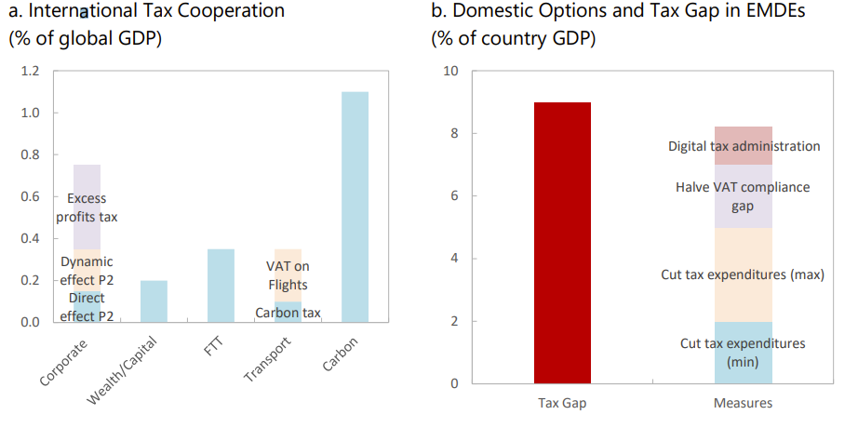Achieving the SDGs will require significant revenue mobilization—both from internationally coordinated taxes and domestic taxes. International cooperation on taxation can play an important role in raising revenue but will be insufficient to address SDG spending needs. Boosting domestic revenue mobilization is challenging but feasible. (Figure; Source: IMF 2024) Harnessing the mandates and expertise of international fora and organizations—such as the new Joint Domestic Resource Mobilization Initiative (JDRMI) of the IMF and the WBG—will be crucial.

References:

Benitez, Juan Carlos, [Mario Mansour,](https://www.imf.org/en/Publications/Publications-By-Author?author=Mario+Mansour&name=Mario%20Mansour) [Miguel Pecho,](https://www.imf.org/en/Publications/Publications-By-Author?author=Miguel+Pecho&name=Miguel%20Pecho) and [Charles Vellutini](https://www.imf.org/en/Publications/Publications-By-Author?author=Charles+Vellutini&name=Charles%20Vellutini). 2023. “Building Tax Capacity in Developing Countries.” IMF Staff Discussion Note SDN 2023/006 (<https://www.imf.org/en/Publications/Staff-Discussion-Notes/Issues/2023/09/15/Building-Tax-Capacity-in-Developing-Countries-535449>).

Black, Simon, Ian Parry, Sunalika Singh, and Nate Vernon-Lin. 2024. “Destination Net Zero: The Urgent Need for a Global Carbon Tax on Aviation and Shipping”. IMF Staff Climate Note 2024/003.

Gaspar, Vitor, Laura Jaramillo, and Philippe Wingender. 2016. “Tax Capacity and Growth: Is There a Tipping Point?” IMF Working Paper WP/16/234 (<https://www.imf.org/external/pubs/ft/wp/2016/wp16234.pdf>).

Grote, Martin and Jean-Francois Wen. 2024. “How to Design and Implement Property Tax Reforms” IMF How to Note 24/06.

IMF. 2024. “Alternative Options for Revenue Mobilization.” Note for the G-20 (<https://www.imf.org/external/np/g20/062424.htm>).

IMF. WBG. 2024. “Stepping Up Domestic Resource Mobilization: A New Joint Initiative From the IMF and WB.” Note for the G-20 (<https://www.imf.org/-/media/Files/Research/imf-and-g20/2024/domestic-resource-mobilization.ashx>).

NB please also provide a 75-word summary of the brief for the website.

*This Brief by the IMF emphasizes the need for developing countries, particularly low-income developing countries (LIDCs), to enhance their tax capacity to achieve Sustainable Development Goals (SDGs) and maintain debt sustainability. With LIDCs requiring an additional 16% of GDP annually in spending to achieve the SDGs, countries need to broaden their tax bases, improve tax compliance, and leverage technology to improve revenue administration. Further progress on international tax cooperation is needed but is insufficient to address countries’ SDG spending needs.*