# SINTEF’s input to the Elements Paper for Financing for Development

SINTEF, located in Norway, is one of Europe's largest research institutes, with multidisciplinary expertise within technology, natural sciences and social sciences. SINTEF is an independent foundation which, since 1950, has created innovation through development and research assignments for business and the public sector at home and abroad.

The SINTEF foundation is a non-profit research foundation. Its purpose is to contribute to the development of society through projects guided by the UN Sustainability Goals. We have over 2,200 employees from 80 nationalities and 7 out of 10 employees are researchers. Every year we conduct 7000 projects for 3000 customers.

Our experience from working with development and implementation of innovations and technology, is that there is a huge potential in a more systemic diffusion of technology between the developed and the developing world. We need to look at science and technology and development together, not as separate entities that seldomly touch upon each other. A closer link between technology and development, will in our experience also ensure reciprocal partnerships (we learn just as much as our partners in the developing world). It is not about exporting an innovation or technology, it is about supporting and enabling communities and regions to develop technologies that meet their needs.

One of the main challenges in achieving this is the lack of mechanisms to spread technology and innovation between the developed countries and the developing countries. Development cooperation is not focused on technology or research institutes, large research programmes through for example Europe is mostly working in developed countries and our industry partners are not familiar with the new markets and its possibilities.

Below we will present four suggestions to increase the spread of technology and innovation between Europe and developing countries.

## SINTEFs suggestions to financing for development

1. **Inspiration from Horizon Europe in development cooperation**

***Open competitive calls as a tool for triggering projects that create impact***

Innovation is the driver of Development. The world’s largest innovation program is Horizon Europe (HEU), with a budget exceeding 90 billion Euro, a renewed strategy every 8 years and more than 30 partner countries involved. Why not take inspiration from HEU when setting up a strategic framework for solving global challenges at the global level?

In HEU the focus is on building value chains, public and/or private, using the combined innovation capacity of the participating nations. This is done by means of open transparent calls. The calls are based on a strategic agenda developed involving all stakeholders in an open and transparent process, ending with policy makers alone deciding its content. The calls state the identified societal challenges and the innovation actors respond by forming consortia and design projects to solve them. Only the best projects evaluated according to concept, team quality and expected impact are funded.

Translated to an equitable partnership approach between a set of countries from developing and developed countries it would start with the involved actors sitting down together to decide on a set of challenges linked to concrete value chains to be developed. The first stage should be open and transparent and include all relevant actors to ensure a best possible base for writing calls. The public funding entities then retreat to their chambers to write the open competitive calls that the innovation actors and the industry from all partners respond to. The public funding offered by means of open competitive calls are trigger funding for risk funding from the private sector. This way the public funding directed at solving societal challenges triggers private funding to achieve the goals set by the public. Open competitive calls also serve as a prevention against corruption as there is a clear separation of funders and recipients of funds, and that the whole process of creating calls and selecting the best projects are based on known criteria, is transparent.

***Sustainable development needs innovation capacity to build value chains***

Developing value chains require innovation capacity (knowledge, applied research, implementation), so depending on the different participants level of development the challenges (and calls) will have to include building innovation capacity to ensure a sustainable value chain.

This is illutrated in the following model:

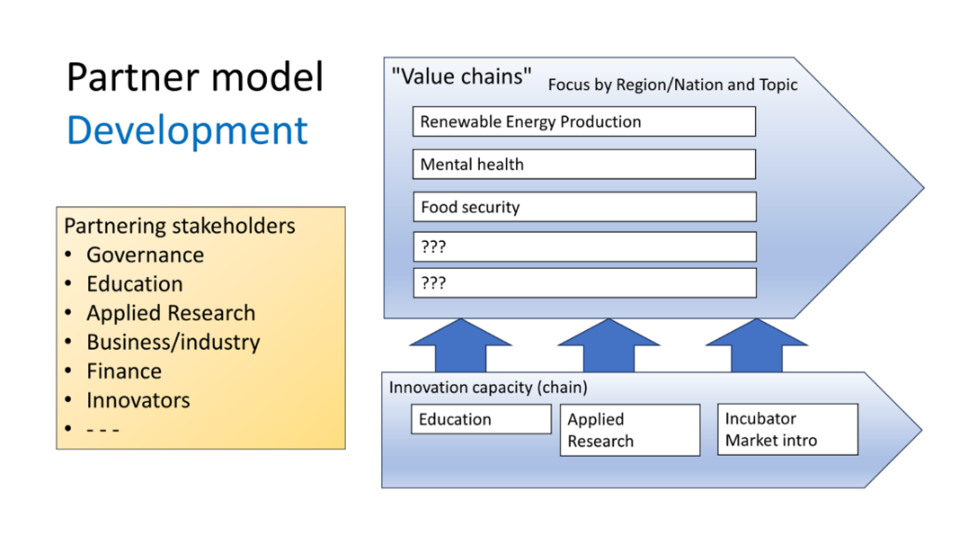

Innovation actors are typically universities, research institutes and businesses developing new products and services put to work in a market or i the public sector. Universities build new knowledge, research institutions use it to create new products and services, and the businesses put them to work in a market. Along this innovation chain these actors overlap and work together as teams. Together they build new or re-new value chains.

In development it is important to assess the availability of each partner country’s innovation capacity, if it’s lacking it needs to be built in parallel to building the focused value chain.

1. **Inspiration from Norwegian Research Council: Innovation projects for industry**

We suggest that to increase the involvement of private industry (both in developed and developing countries), development cooperation looks at the financial mechanisms in for example innovation projects for businesses from the Norwegian Research Council. These innovation projects are designed to support businesses who wish to develop new products, services or solutions that can increase their value and competitive advantage. In order to get funding, the industry has to contribute typically 50 percent of the total costs of the project. Often, the industry will put in the human resources and working hours, while the research council will cover the costs for research institutes that support the industry in becoming greener.

The calls have specific thematic areas they focus on, for example energy, transportation, oceans, food and biodiversity. The calls are attractive to private industry, because it allows them to develop new and sustainable solutions together with researchers who are “sponsored” by the research council.

SINTEF, being an applied research foundation, has vast experience working in innovation projects with industry and our experience is that it is one of the best ways to make sure technology is actually put into use.

We also have experience working in similar ways in low- and middle-income countries. In these projects, public funding covers the costs of SINTEF and potential other research partners to work on implantation and development of specific technologies in low- and middle-income countries. The industry partners in the country cover their own costs for joining the project, including necessary equipment for utilizing the technologies. They are willing to do so because they get access to world-leading technology and innovation competence from research institutes who support them in developing the technologies to meet local needs and implement it.

Our suggestion is that these kinds of calls are implemented as pilot projects in certain development cooperation agencies, demanding in-kind financial contribution from industry both in developed and developing countries.

1. **Partners from developing countries as a demand in Horizon Europe calls**

Technology development is mostly happening in developed countries, and diffusion to more developing countries is slow or lacking. Europe has one of the world's largest research programmes, Horizon Europe. Horizon Europe projects welcome the participation of “third countries” outside of Europe (financial schemes vary depending on country), and has some specific calls aimed at Africa and India for example. However, the majority of projects only have European partners, and the development and implementation of technology and innovation happens in Europe.

We suggest that to spread the use of technology to achieve a global green and digital transition, the EU demands participation of partners from low- and middle-income countries in projects funded through Horizon Europe. This way research partners and industry in developing countries can collaborate closely with colleagues in Europe and other countries, and together adapt technologies to meet local needs in their respective regions.

Horizon Europe is already a hugely successful platform, and it should be made better use of to ensure a more global spread of technology and innovation competence. It should be a “low hanging fruit” to achieve more global technology development.

The Norwegian Research Council also have a compensation scheme named "Retur-EU" for participation in Horizon Europe. The scheme compensates for some of the gap between EU funding and actual costs for Norwegian research institutes, which accounts for a large part of Norwegian participation in Horizon Europe. Similar compensation schemes could be developed to ensure participation of research institutes from developed countries in the UN-system and other international development cooperation initiatives.

1. **Technology and innovation funds**

We suggest increasing the use of technology funds to ensure a better diffusion of technology to developing countries. There are some good examples of funds who focus on spread and implementation of technology, such as USAID’s “Development Innovation Ventures”, “Global Innovation Fund” and France’s “Fund for Innovation in Development”. The financing of the funds varies from public, private and philanthropical funding.

Our experience is that there are many technologies and innovations in the developed world, that could be adapted and implemented in more developing regions and would have a large and positive impact on especially climate and biodiversity. Examples can be found within areas such as sustainable agriculture, nature-based solutions for climate adaption, waste management, renewable energy and sustainable fisheries and aquaculture.

However, the spread of technology is slow or lacking. One main challenge is that there is a lack of instruments to finance implementation of technology with partners in the developing world. Although there are some funds financing innovation in these regions, they are fragmented, few and far between.

We suggest that regions in developed countries, such as Scandinavia, create regional funds for implementation of innovation and technology in low- and middle-income countries. Partners from developed and developing countries can together apply for projects to ensure a better diffusion of technology and a true global green transition.