UNCTAD Financing Brief for FFD4

Harnessing Science, Technology and Innovation for Equitable Global Development: A Pathway to Achieving the SDGs

Key messages (suggested word count: no more than 200 words)
- Integrating STI into Financing for Development: STI are critical enablers for achieving the SDGs and must be central to the Financing for Development agenda. Without substantial investments in STI, countries will struggle to meet their development objectives and respond to global challenges including climate change and pandemics.
- Opportunities and risks of technological disruption: While frontier technologies create new opportunities, especially for developing nations to leapfrog development stages, they also disrupt traditional growth pathways and exacerbate inequalities if not managed properly.
- Implementing policies that direct technology towards creating labour-absorbing sectors and high-quality jobs: The international community should implement policies to harness frontier technologies for inclusive growth, ensuring that benefits are widely shared, lifting people out of poverty, and strengthening the middle class.
- Addressing inequalities in STI requires an enabling multilateral environment. This includes fostering improved access to technology, strengthening South-South cooperation, promoting open science, and flexible IPR regimes, while maintaining an open, rules-based multilateral system that supports developing countries’ technological development.
- Using finance to close technological gaps: Strategic financial investments at national and international levels, including the mobilization of ODA, are crucial to closing technological gaps. By mobilizing public and private finance, countries can enhance their technological capacities, improve infrastructure, and foster innovation.

Problem statement (500 words)
The pursuit of the United Nations’ Sustainable Development Goals (SDGs) is heavily dependent on technological advancements. Without substantial progress in technological advancements and access to technology, many countries will struggle to achieve the SDGs, leaving them unattainable for large portions of the global population.
Technological advancements, particularly in digital and green technologies, are reshaping the patterns of international comparative advantages, disrupting traditional pathways to growth and development. However, these disruptions also present new opportunities for developing economies. Countries that can successfully adapt to the evolving technological landscape may benefit from bypassing traditional stages of industrialization and moving to more advanced development stages. This shift opens up new areas of comparative advantage that extend beyond traditional manufacturing, moving into increasingly globally tradable services and intangible assets.
However, to harness these potential benefits, essential pre-conditions must be in place. A skilled workforce, robust R&D ecosystems, technology infrastructure, and appropriate regulatory frameworks are critical for leveraging these technologies equitably. Effective governance structures are also necessary to coordinate among stakeholders, ensure policy coherence, and promote accountability and transparency in STI initiatives.
Despite the opportunities, technological innovations pose significant risks if these pre-conditions are absent. Digital technological progress has led to unprecedented levels of market concentration. A small number of firms operating at the technological frontier and based almost exclusively in two large economies have captured a disproportionate share of profits, exacerbating global inequality. The increasing substitution of labour with technology, particularly AI, has weakened workers’ economic and political power. This shift, combined with hyper-globalization and austerity policies, contributes to the erosion of the middle class in developed countries and premature deindustrialization in developing nations.
As businesses increasingly favour capital-intensive, winner-take-all models that prioritize labour substitution, income distribution has become increasingly skewed. A larger share of income is now flowing to capital rather than labour, deepening economic inequality. The uneven distribution of technology limits the ability of less developed nations to respond effectively to crises such as climate change, pandemics, and geopolitical conflicts. Global divides in access to technology also have profound implications for global inequalities, contributing to increased societal polarization, growing political discontent, and a weakening of trust in existing government institutions.
Addressing these inequalities is not just a matter of fairness. It is a critical developmental issue. If left unaddressed, these challenges could undermine global stability and hinder further progress toward the SDGs. Therefore, there is an urgent need for a more coordinated and inclusive approach to technological advancement and diffusion. Policymakers must prioritize strategies that ensure the benefits of technology are widely shared across societies. By leveraging technology for broader societal benefits, we can address the root causes of inequality head-on and build a more just and sustainable future for all.

Policy solutions (500 words)
While development is primarily the responsibility of national governments, an enabling international environment is crucial for supporting these efforts. Developing countries often lack the resources, infrastructure, and technical expertise to fully leverage advanced technologies.
Addressing complex global crises, such as climate change, pandemics, and economic instability, requires coordinated international efforts and sustained investments in Science, Technology, and Innovation (STI), including the mobilization of Official Development Assistance (ODA) (Figure 1). This is especially critical for developing countries, which are often the most vulnerable to these crises yet have the least capacity to respond effectively. Developing economies need stronger commitments to finance R&D, as they spend significantly less than the world average. Their R&D spending ranges from 0.20% to 0.86% of GDP—a small fraction compared to developed regions.
Figure 1. Share of official development assistance related to science, technology, and innovation, 2002–2022
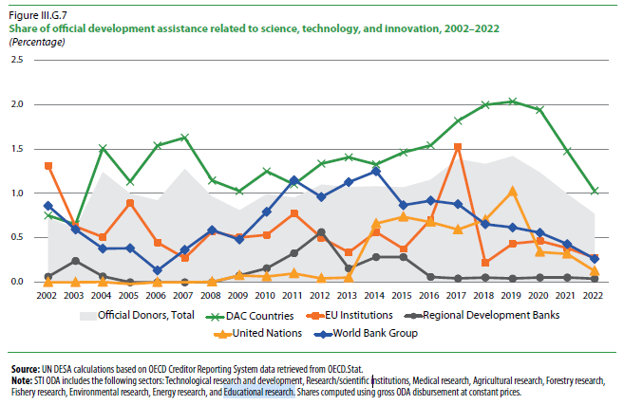
Concentrated innovation and weak technology diffusion highlight the call for policies to improve access to new technologies. This involves investing in education, training, infrastructure, and institutions that enhance both innovation and the ability to absorb new technologies. Competition policies should be invigorated and address the intrinsic monopolistic nature of digital platforms. They need to look beyond traditional metrics like revenue and operational growth and scrutinize the acquisition of data and users, which have become key resources in the AI era.
Global solutions should be in place to ensure equitable access to knowledge. The COVID-19 pandemic underscored the importance of making scientific knowledge widely accessible. The rapid sharing of research findings and data was crucial for understanding the virus and creating vaccines. However, the pandemic also revealed significant gaps in access to scientific knowledge. Much of the research remained locked behind paywalls, limiting the ability of nations to respond effectively to the pandemic. Given the urgency of climate change, free access to scientific knowledge can be a matter of survival. The international community needs to develop a global solution to ensure that publicly funded research is freely accessible to all and fully commit to open science.
It is crucial to protect a rules-based multilateral system for trade and investment from the rising pressures of protectionism and zero-sum game policies. Policymakers may be tempted to promote national AI champions to drive domestic development. However, there should be a careful balance, as protecting monopolies, including those in AI, can threaten global prosperity by concentrating risks in supply chains, weakening industry resilience, reducing innovation, and raising prices. Local champions could be more competitive internationally when they are driven to be efficient and innovative by domestic competition policies. It is essential to avoid a zero-sum approach, viewing digital technologies not as tools for dominance but as opportunities for shared growth and development.

Specific recommendations for FFD4 (300 words)
To harness the potential of STI, pre-conditions like human capital development, R&D capabilities, technology infrastructure, and regulatory frameworks are necessary. Facilitating climate-resilient technology transfer through international partnerships and mechanisms like the Technology Facilitation Mechanism, and mobilizing technology finance globally and nationally, is crucial. While increasing ODA for STI is important, pursuing other R&D financing mechanisms—leveraging domestic resources, private sector participation, and innovative financing solutions—is essential. South-South cooperation offers opportunities for shared learning and technology transfer, enhancing regional capacities.
Mandating global open access to publicly funded research is necessary to boost STI for development. Making scientific knowledge universally available bridges existing knowledge gaps and empowers nations to respond more effectively to global crises.
To combat climate change, the IPRs should align with the UNFCCC’s principle of “common but differentiated responsibility and respective capabilities.” This would allow less technologically advanced countries to imitate production methods from more developed economies. The IPR system should also become more flexible to support climate action.
The outcome document of the Fourth Conference on Financing for Development should include a clear commitment to ensuring that all countries have equitable access to technologies and scientific knowledge. This commitment should be supported by international cooperation, funding mechanisms, and open access policies. It should advocate for the dissemination of technologies considered global public goods, especially those addressing climate change and environmental sustainability, making them accessible to all countries regardless of economic status.
While global action is needed to create favourable conditions for states to drive the development agenda, it is essential to recognize that development is primarily the responsibility of national governments. Finally, the document should outline specific policies that channel technological progress toward the creation of labour-absorbing sectors and middle-class jobs, ensuring that technological advancements contribute to broad-based economic growth and social development.
NB please also provide a 75-word summary of the brief for the website.
Integrating Science, Technology, and Innovation (STI) into Financing for Development is essential for achieving the Sustainable Development Goals (SDGs). While technological advancements offer opportunities, they can disrupt growth pathways and increase inequalities if mismanaged. Key recommendations include directing technology to create middle-class jobs and labour-absorbing sectors, improving access to scientific knowledge and technological innovations through open science and flexible intellectual property regimes, fostering South-South cooperation, and mobilizing development financing, including Official Development Assistance (ODA) to close technological gaps.

United Nations, 2021, The Sustainable Development Goals Report (United Nations publication, New York)
United Nations, 2024, Financing for Sustainable Development Report 2024: Financing for Development at a Crossroads (United Nations publication, New York)

