UNCTAD Financing Brief for FFD4
Ensuring Trade Inclusivity for Sustainable Development

Key messages
- Trade has long been a key driver of economic growth, income generation, employment, and poverty reduction. Active participation in global value chains and a competitive private sector typically facilitates fiscal resource mobilization. However, the rise of unilateralism and protectionism is undermining the multilateral trading system and runs counter to World Trade Organization (WTO) rules.
- Major economies are implementing inward-looking subsidies to support their transitions to a green and digital economies. Such policies favor local suppliers, diverting trade from developing countries and limiting their growth potential through their integration into global supply chains.
- This trend has undermined the trust in the multilateral trading system, which is essential for global trade and for developing countries to reap the potential of trade as an engine of economic growth and financial stability.
- Financing infrastructure in developing countries is essential for enabling their participation in the dual transition, allowing them to join supply chain relocation efforts and capitalize on international trade opportunities, fostering sustainable and inclusive growth.
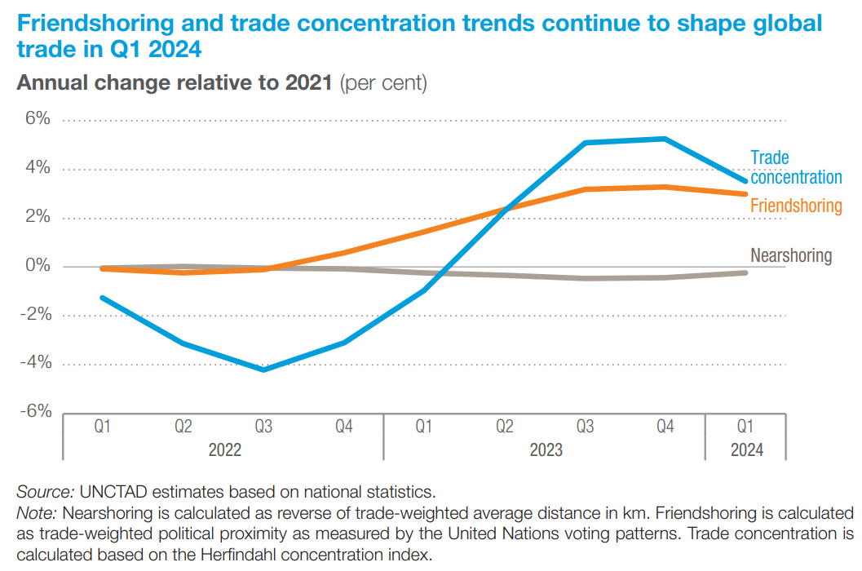

Problem statement
The restructuring of global value chains aims to enhance resilience, reduce vulnerabilities, and support the transition to a green and digital economy as the world seeks to reduce carbon emissions. Between 2002 and 2023, global merchandise trade nearly quadrupled, and trade in services more than doubled. However, benefits were not evenly distributed. In fact, Least Developed Countries (LDCs), Small Island Developing States (SIDS), and Landlocked Developing Countries (LLDCs) have not benefited equally from this growth, facing high trade costs and significant challenges in accessing global market. For example, the share of least developed countries (LDCs) in global exports has stagnated at around 1% since 2011 despite some growth in absolute terms, and LDCs are not on track to reach the Sustainable Development Goal target of doubling their share in global exports by 2030.
To benefit from international trade, developing countries must secure their niche in global supply chains, increasingly shaped by the green and digital transitions, which are facilitated by industrial subsidies mainly offered by developed countries. Developing country participation in today’s global value chains also requires significant investment in state-of-the-art infrastructure, including transport, logistics, telecommunications, and clean energy—making access to affordable finance crucial. However, developing countries face a $208 billion annual gap in transport infrastructure investment, must reduce trade costs still equivalent to 100% tariffs, close a $990 billion digital divide, and secure $4.7 trillion for clean energy by 2030. In addition, rising borrowing costs are a major hurdle, with bond yields in Africa averaging 9.8% from 2020-2024, compared to 0.8% in Germany.
Even if regional development banks have established global infrastructure funds to assist developing countries, attracting private investment and securing long-term financing remains challenging. Without substantial investment, developing countries risk being left behind in global supply chains and the digital economy, further exacerbating inequalities in access to trade opportunities.
Financing for infrastructure. Developing countries must address the infrastructure gap to participate in today’s global supply chain relocation. UNCTAD estimates the annual transport infrastructure investment gap at $208 billion. This investment is vital to enhance physical infrastructure within and between regions, enabling better trade integration.
Financing border crossings and customs facilitation is a key area for developing countries’ participation in supply chains. Investing in infrastructure is crucial to reducing delays and high trade costs, which remain equivalent to 100% tariffs for developing countries as of 2021.
Financing to close the connectivity gap. The digital divide also hampers participation in global value chains and threatens to deepen the gap between developed and developing countries. Despite the rapid advancement of digital trade worldwide, many developing nations continue to lack the infrastructure, skills, and regulatory frameworks necessary to take advantage of trade in goods that increasingly depend on services and in the digital economy. Developing countries will need over $990 billion by 2030 to invest in digital infrastructure, skills, and regulatory frameworks. Multilateral Development Banks can provide financing, with private investors contributing through public-private partnerships (PPPs).
Financing the transition to clean, renewable, and affordable energy for clean production. The transition to clean, renewable energy is equally pressing, requiring an estimated $4.7 trillion by 2030. This investment is essential for sustainable production in global value chains.

Policy solutions
To ensure that developing countries can fully participate in reshaped globalization, financial resources must be directed toward building infrastructure that closes the digital divide and facilitates the transition to renewable energy. Financing projects that connect developing countries with their neighbors can boost regional trade and investment, enhancing competitiveness through greater collaboration and integration into regional supply chains.
To secure funding for enhanced trade and development, an infrastructure fund should be established to finance such projects, leveraging bond markets, including green bonds, to attract long-term investment in sustainable initiatives. Multilateral development banks and governments could offer concessional loans and grants to lower financing costs, while Public-Private Partnerships (PPPs) can combine concessional finance with private capital to de-risk investments and attract private sector participation. Key financial instruments include:
- Establishing a developing country infrastructure fund, financed through bonds, including green bonds, for long-term projects that allow developing countries to move to a green and digital economy.
- Offering concessional loans and grants from international financial institutions and developed governments to reduce infrastructure financing costs.
- Leveraging PPPs to combine concessional finance with private capital, sharing both risks and rewards.
Closing the infrastructure gap requires regional planning and coordination to prioritize cross-border infrastructure projects and enhance connectivity. Strengthening institutional capacity is also essential for better governance, planning, execution, and maintenance of infrastructure.
Closing the connectivity gap requires regulations to facilitate cross-border digital transactions and protect data privacy. Significant loans and grants from multilateral development banks (MDBs) should be mobilized for telecom and connectivity projects, with targeted incentives to attract private investment from telecom and technology firms. National governments should prioritize digital infrastructure with long-term investments.
Financing the Transition to Clean, Renewable, and Affordable Energy will require aligning national energy policies with global climate goals, promoting renewable energy adoption, and phasing out fossil fuels. Green bonds should be issued for renewable energy projects to attract environmentally conscious investors, while international climate funds, like the Green Climate Fund, should provide concessional financing for large-scale renewable projects. PPPs can help distribute the financial burden of clean energy projects while ensuring economic viability.
Moreover, for developing countries to attract investment, integrate into global value chains, and leverage the twin transitions through export-led strategies, a strong multilateral framework of trade rules will be required. Restoring the credibility and effectiveness of the WTO is essential for transparent, predictable, and non-discriminatory trade rules. This includes reinstating the full functionality of the WTO Dispute Settlement Mechanism.

Specific recommendations for FFD4
The Fourth Conference on Financing for Development (FFD4) offers a crucial opportunity to tackle the financing challenges related to the reconfiguration of global value chains. A proposed solution is the establishment of an infrastructure development fund for developing countries focusing on critical projects to enable them to take part in the dual transition to a green and digital economies, and hence be able to have a place in global supply chains. This requires heavily investing in transportation, telecommunications, energy, and digital infrastructure, enhancing connectivity and integration into global value chains.
Financed through a specialized vehicle, the fund would pool resources from multilateral development banks (MDBs), national governments, private investors, and international donors. It would offer a mix of financial instruments like long-term bonds, green bonds, concessional loans, and grants to reduce capital costs. The fund’s governance would emphasize transparency, accountability, and efficient resource allocation, with mechanisms to attract private sector participation through public-private partnerships (PPPs).
Key areas of investment include:
1. Physical Infrastructure: Upgrading transportation infrastructure (roads, ports, railways) to reduce logistics costs and improve market access.
2. Border Infrastructure: Enhancing border facilities and customs systems to streamline cross-border trade.
3. Connectivity Infrastructure: Developing digital infrastructure (broadband, data centres) to boost e-commerce and digital trade.
4. Energy Transition: Supporting renewable energy projects to ensure sustainable energy supply and zero-emission production.
Supporting green infrastructure aligned with global sustainability standards can attract investment focused on environmental, social, and governance (ESG) criteria.
FFD4 should also advocate for World Trade Organization (WTO) reforms that address developing countries' needs, ensuring they benefit from a universal, rules-based, open, non-discriminatory and equitable multilateral trading system under the World Trade Organization. Strengthening the WTO’s oversight and restoring its Dispute Settlement Mechanism is crucial for maintaining a level playing field, particularly amid the transitions to a digital economy and green energy. A strong multilateral trading system is the best safeguard for developing countries' participation in global value chains and in international trade.

Summary:
Trade is vital for economic growth, but protectionism and unilateralism threaten the global trading system, limiting developing countries' participation. These nations face challenges in competing with developed economies' subsidies for green and digital transitions and struggle to secure financing for infrastructure. To enhance their role in global value chains, developing countries require substantial investment in transportation, energy, and digital infrastructure. A specialized infrastructure fund, supported by multilateral development banks and private capital, is crucial to closing this financing gap.

UNCTAD, SDG Investment Trends Monitor, Issue 4, Appendix 1. September 2023.
World Bank, World Economic prospect 2021.
Ibid.
Ibid.

