UNCTAD Financing Brief for FFD4

Better data on trade in services for effective financing for development strategies

Key messages (no more than 200 words)
- Trade in services is a key driver of cross-border financial flows for developing countries. As digitalization transforms previously non-tradeable services into tradeable ones, the rapid growth of services trade continues outpacing merchandise trade, further increasing its significance in developing countries' current accounts.
- However, the lack of comprehensive data on trade in services may obscure the real challenges developing countries face in mobilizing finance for development, potentially leading to an overestimation of domestically available finance and an underestimation of their services trade deficits. This makes it difficult to fully understand and address their financial needs.
- FfD4 may emphasize the importance of strengthening developing countries' capacity to identify, collect, and analyze services trade data, enabling more accurate assessments of their resource mobilization potential.

Problem statement (500 words)
The Addis Ababa Action Agenda confirms that international trade is an engine for inclusive economic growth and poverty reduction and contributes to the promotion of sustainable development (Paragraph 79). Trade is also an important generator of cross-border private financial flows and forms a critical component of a country’s current account. As illustrated in Figure 1, from 2005 to 2023, net merchandise trade made up 76 per cent and net services trade 13 per cent of the current account for developing countries. Among developing countries, those in sub-Saharan Africa demonstrate a high share of secondary income (or current transfer), which includes official development assistance (ODA).

Figure 1: Net trade accounts for the lion’s share of the current account, by sub-category and region, 2005-2022 (percentage)

Source: UNCTAD calculations based on IMF BOP statistics.
Note: Country groups follow definitions of the International Monetary Fund (IMF): developing economies include emerging and developing economies and developed economies include advanced economies.

The weight of services in the current account is expected to increase in the coming years as the services trade has been growing at a faster rate than the merchandise trade across the world. A significant driver of services trade growth is digitalization. Digital technologies have caused a paradigm shift in how services are supplied and consumed across borders. On the supply side, new data networks, digital tools, and platforms have transformed previously non-tradable services, such as education and training, health services and agricultural extension services.
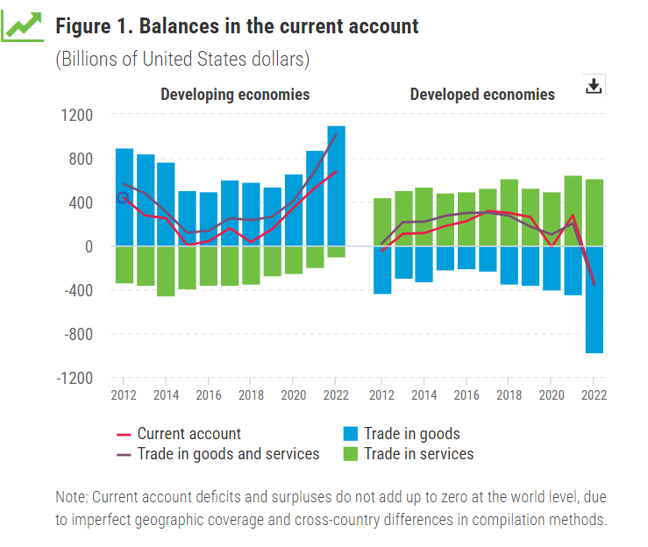
However, the services trade is grappling with a significant measurement issue. Many developing economies lack in comprehensive trade services data. According to UNCTAD’s assessment of official statistics of 188 economies available as of July 2023, fewer than 10 developing economies regularly publish services trade data disaggregated by trade partners. The International Monetary Fund Balance of Payments and International Investment Position Manual, 6th Edition (BPM6) categorises services into twelve major items and (a number) of subcategories. However, around two thirds of developing countries report data that extends beyond the 12 main Balance of Payments (BOP) items, compared to 96 per cent reported by more advanced economies.
The lack of comprehensive data on trade in services may obscure the real challenges developing countries face in mobilizing finance for development, which in turn may lead to overestimating the domestically available finance in developing countries. The available data suggest that developing countries import more services than they export (Figure). However, missing accurate data may lead us to underestimate the extent of their services trade deficits, making it difficult to fully understand and address their financial needs.
While collecting merchandise trade data from the customs data is straightforward, collecting data on services trade is complicated. A conventional data collection method has been through an international transactions reporting system (ITRS). An ITRS allows central banks to compile services statistics with information from domestic banks on international transactions. However, data obtained through ITRS are too aggregated to meet the standard suggested by the Manual on Statistics of the International Trade in Services 2010 (MSITS 2010).
As services trade transactions take various forms, including transactions between private firms, collecting detailed and disaggregated data requires conducting surveys by national statistical offices (NSOs). In developed economies, surveys are replacing ITRS for collecting services trade data. NSOs send surveys to resident businesses listed in the national business or enterprise register. Administrative sources of data, such as employment, tax records or population registers, and firm-level big data, can complement the surveys.
The use of surveys and administrative or firm-level data is not yet widespread in developing countries as many of them lack crucial data and statistical infrastructure, such as statistical business registers and the necessary information technology capacity to handle large data volumes. The lack of trust among respondents, particularly concerning disclosing financial information, can also present challenges when collecting data through several of these sources and methods.

Policy solutions (500 words)
Ways to improve the collection of services trade data are well documented and tried, as discussed below.
Building services trade statistical capacity: There are tools that help developing countries build capacity in identifying, collecting and assessing services trade data. The Trade in Services Information System (TiSSTAT), developed by UNCTAD, includes modules for survey management, data entry, cleaning, compilation, quality assurance and dissemination and allows collecting data on bilateral trade flows and modes of supply. The Handbook on Measuring Digital Trade published jointly by the IMF, the Organization for Economic Cooperation and Development (OECD), UNCTAD, the World Bank, and the World Trade Organization (WTO), provides standardized guidelines for collecting and reporting digitally-delivered services trade.
Improving or expanding data source: Foreign affiliates trade statistics (FATS) provide information on foreign affiliate firms operating in a host country which includes the net primary (factor) income in the current account. Countries can design the system to collect information on services delivered by foreign firms with a physical commercial presence in host countries. Value-added tax (VAT) data may provide information on bilateral services trade through foreign affiliation, ownership, employment, and income sources (domestic or foreign). Statistics Finland and the Turkish Statistical Institute (Turkstat) use VAT data to complement surveys to provide estimates for non-surveyed firms. The United Nations Economic and Social Commission for Asia and the Pacific (ESCAP) investment data collected by the Financial Times to track activities of foreign affiliate firms and investment projects to complement traditional BOP data for the analysis in the Asia-Pacific Trade and Investment Report 2023/2024.
Integrating firm-level and big data: Using firm-level big data offers a promising avenue for enhancing services data collection. This approach complements targeted surveys by requiring specific statistical methods, advanced information technology to manage large volumes of unstructured data, and a legal framework that permits access to private data for statistical purposes. Digitally deliverable services, such as payment cards and mobile phones can be relevant sources of big data. For instance, in Indonesia, the NSO employs mobile phone roaming data to improve tourism statistics such as the country of origin, time of arrival and departure, gate of entry and departure, length of stay, and destination countries. The Voorburg Group on Services Statistics, created in 1986 to respond to a request from the United Nations Statistical Office to assist in developing services statistics, aims to “establish and maintain an internationally comparable methodology for measuring output and producer price indexes for the service industries”. In addition to traditional surveys, the Group uses diverse services data sources such as administrative data sources, corporate datasets, bank and credit data, and web scraping.
While valid, these approaches are currently isolated cases. It requires the international community’s concerted support to significantly improve developing countries’ data capacity and make their financing-for-development strategies more data-driven and evidence-based.

Specific recommendations for FFD4 (300 words)
The paragraph 126 of the Addis Ababa Action Agenda calls on relevant institutions to “strengthen and standardize data on domestic and international resource mobilization and spending, as well as data on other means of implementation”. Building upon the efforts so far achieved, the Fourth Conference on Financing for Development (FFD4) may consider the following recommendations.
FFD4 to:
- Reconfirm the pivotal role of trade as an engine for development, offering a promising pathway to strengthening domestic capacity for financing development.
- Recognize the critical role of robust data in financing for development, particularly the need for developing countries to have the capacity to collect and assess services trade data.
- Urge the international community to support the development of the data and statistical infrastructure necessary to collect and handle data, including large data volumes.
- Promote sharing good practices in collecting and analysing services trade data and statistics for financing-for-development policymaking.
-- --

UNCTAD (2021), Digitalization of services : What does it imply to trade and development ? (UNCTAD/DITC/TNCD/2021/2).
UNCTAD (2023), Handbook of Statistics 2023, Economic trends: Current Account.
United Nations Department of Economic and Social Affairs (2012), Manual on Statistics of the International Trade in Services 2010 (ST/ESA/M.86/Rev. 1). The MSITS 2010 provides “an internationally agreed framework for the compilation and reporting of statistics of international trade in services (…) for more detailed, more comparable and more comprehensive statistics” of services trade.
The information provided in this section is based on the UNCTAD informal Working Group on Data for Services, Trade and Development Policies findings. Since its establishment in 2022, the group has been dedicated to discussing services trade data gaps, showcasing innovative ways to use existing data as a proxy for services trade data, and sharing good practices.
UNCTAD developed the tool in a joint project with the West African Economic and Monetary Union (UEMOA) and its member States.
UN ESCAP (2023), Asia-Pacific Trade and Investment Report 2023/2024: Unleashing digital trade and investment for sustainable development (ST/ESCAP/3107).
Lestari, et al. (2018). Indonesia’s experience of using signaling mobile positioning data for official tourism statistics. Conference Paper.

