# Rationalising Tax Expenditures – a Core Element of Financing for Development

# Input for an Elements Paper in Preparation of the Fourth International Conference on Financing for Development (FfD4)

# *Authors: Christian von Haldenwang and Agustín Redonda[1]*

**Abstract**

The Fourth International Conference on Financing for Development (FfD4) needs to address the issue of tax expenditures. These preferential tax treatments cause huge immediate public revenue losses while their effectiveness is often in doubt. Governments need to act on several fronts: First, publish regular and comprehensive reports on the tax expenditures they use. Second, set up and implement evaluation frameworks that subject all tax expenditures to regular scrutiny. Third, agree on methods and data to estimate revenue forgone from tax expenditures, in order to improve the reliability and comparability of data.

1. **Introduction: The Relevance of Tax Expenditures**

Governments worldwide use preferential tax treatments – called tax expenditures – to pursue different policy objectives, such as attracting investments, promoting employment, fighting poverty or curbing greenhouse gas emissions. This is not a minor issue: According to the most recent data from the [Global Tax Expenditures Database](http://www.GTED.net) (GTED), revenue forgone from such preferential tax treatments amounted to 4 percent of GDP and 23.8 percent of tax revenue in 2021 (Redonda et al., 2024). It is very likely that the real numbers are higher, as non- and underreporting is widespread. First, while the number of countries that report on tax expenditures has been growing over the last decades, still half of all jurisdictions worldwide (109 out of 218) have never issued an official tax expenditure report since 1990, the first year for which the GTED gathers data. Second, even when reports exist, their quality and scope is often far from ideal (Redonda et al., 2023a).

Tax expenditures come in many forms, but they have one thing in common: an immediate loss of government revenue. This said, when tax expenditures are effective, the revenue forgone (or part of it) can be compensated at a later stage by higher levels of investment, economic growth or consumption. Nonetheless, governments often implement tax expenditures without any information about the associated costs – let alone, the benefits they are expected to create. This lack of information at the moment of setting up tax expenditures is often maintained over extended periods of time: so far, only a minority of governments conduct comprehensive evaluations of tax expenditures, including sound cost-benefit analyses or other types of impact assessments (Redonda et al., 2023a).

However limited, the evidence generated by such evaluations and academic research reveals that many tax expenditures are rather ineffective in achieving their stated goals. In fact, they can even be counterproductive or harmful, for instance by creating negative externalities and spillovers with regard to other policy objectives and third countries.

At a moment when governments worldwide are desperately looking for funds to finance policies that help them to meet the Sustainable Development Goals (SDGs) and the commitments made under the Paris Agreement, reforming or dismantling ineffective and harmful tax expenditures appears to be a promising move. Well-designed tax expenditure reforms can serve a two-fold purpose of increasing domestic resource mobilisation (DRM) and creating fiscal space while at the same time better aligning tax systems with governments’ growth and development strategies.

All too often, however, ineffective or harmful tax expenditures are maintained. While several factors are responsible for this, lack of reliable information about the fiscal consequences of tax expenditures and their impact, but also about the tax expenditure regimes of other countries, plays a critical role in this regard. Consequently, more transparency on the use of tax expenditures, and more consistency in categorising and evaluating them are cornerstones of any national and international efforts to address this key dimension of taxation and development financing.

1. **Rationalising Tax Expenditures: Transparency**

Transparency in tax expenditure use serves several purposes. First, given their significant impact on public coffers, estimating and reporting on tax expenditures is necessary for governments to gain a complete picture of public finances and to increase the reliability of their revenue forecasts.

Second, governments that publish reports on tax expenditures tend to dedicate major efforts to the collection of data and information that might otherwise remain dispersed across a large number of governmental bodies. In this sense, governments themselves, and policy-makers in particular, are the first to benefit from transparency as these data are likely to be key to evidence-based policy making.

Third, any public debate on tax expenditures gains from access to information. This is particularly important in those cases where tax expenditures are granted to small groups of companies or individuals who might use their lobbying power to keep certain preferential tax treatments even without any proof of their effectiveness. In this sense, transparency may also contribute to preventing state capture and strengthening the governance of tax policy-making.

Fourth, transparency is also relevant with regard to international tax competition. While governments usually find it easy to get access to information on tax regimes of other countries, this is significantly more challenging with regard to tax expenditures. However, such measures applied in one country can have serious consequences for other countries as well. Hence, it is pivotal to improve the general state of tax expenditure reporting and encourage more countries to publish this kind of information. Indeed, tax expenditure reporting is a core feature in the policy cycle leading to the reform of tax expenditure regimes (see Figure 1).

**Figure 1: The tax expenditure policy cycle**

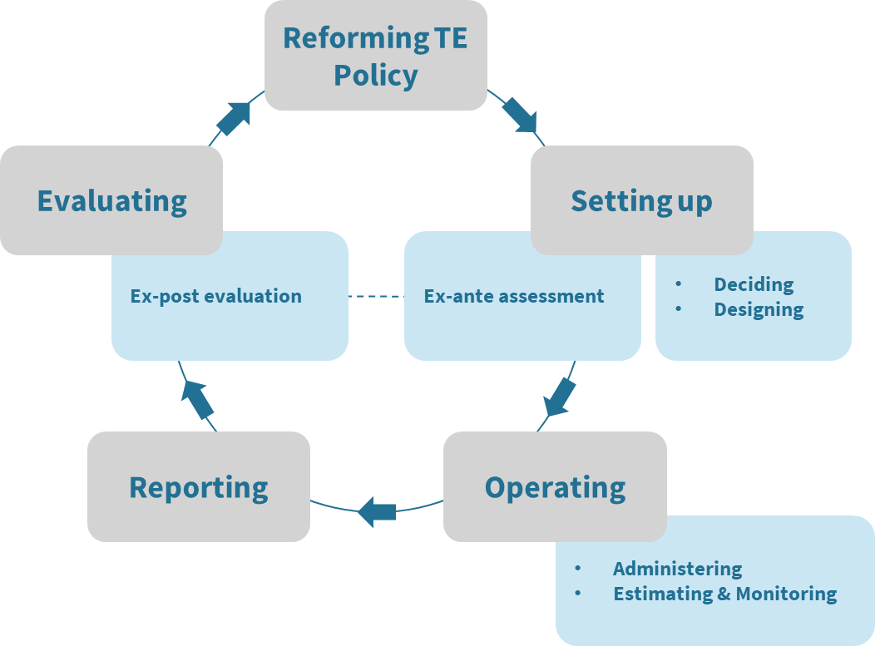

Source: Redonda et al. (2023a).

Governments should publish regular reports covering all the tax expenditures they use. They should provide information on the legal basis of the measures, their objectives and intended target groups, as well as the revenue forgone those measures generate. As a best practice, this information should be made available to the parliament at the moment of annual or semi-annual budget debates and linked to the government’s budget proposal. Only then will the parliament, as well as the broader public, have the factual basis to discuss the use of tax expenditures in a broader context of fiscal policy and budget planning. The [Global Tax Expenditures Transparency Index](https://gteti.taxexpenditures.org/) (GTETI), launched in 2023, is based on a set of five dimensions and 25 indicators that together establish an ambitious, yet manageable framework for good tax expenditure reporting (Redonda et al., 2023b).

However, it is important to understand that annual reports on tax expenditures, while highly relevant from a fiscal perspective, are not the only point in time when transparency matters for a rational use of tax expenditures. For instance, it is key that tax expenditure evaluations (or, at least, their main takeaways) are shared with all the relevant stakeholders and fed into tax expenditure policy making. Even prior to the implementation of tax expenditures, setting up new provisions should also take place in a context of transparency. In this case, transparency should cover the criteria applied and procedures followed in the process, as well as the expected costs, benefits and spillovers generated by the measure.

1. **Rationalising Tax Expenditures: Consistency**

Transparency is a necessary condition for the rationalisation of tax expenditures, but it is certainly not a sufficient one. Consistency is a second dimension that governments need to take into account. In the context of the present input paper, consistency refers to the application of shared standards and regulations that govern the definition of tax expenditures, their evaluation and the estimation of revenue forgone – both domestically and internationally. While governments should be free to apply the tax expenditures they deem necessary or justified under national and international law, they should do so in a way that allows those affected by these policies to understand the nature and scope of the measures.

One important factor to take into account in this regard is the fact that tax expenditures are always granted upon a national benchmark system. The way how benchmarks are being defined and tax expenditures categorised differs widely across countries. To give an example, some governments implement certain across-the-board or lump sum exemptions as tax simplification measures. As such, they are not considered tax expenditures and, consequently, neither estimated nor reported. Lack of consistency in the identification of tax expenditures leads to uncertainty, adds to the complexity of tax systems and may undermine sound fiscal planning. An international glossary and check list could assist governments to identify the tax expenditures they use properly.

Similarly, governments are not always consistent when setting up frameworks for ex-ante assessments or ex-post evaluations. Evaluating tax expenditures requires, at a minimum, running a cost-benefit analysis based on the observed impact of the tax expenditure measure. A comprehensive evaluation design includes identifying spillover effects (both positive and negative) arising from the implementation of tax expenditures. Whereas ex-ante assessments and ex-post evaluations are different in spirit, substance and take place at different stages within the tax expenditure policy cycle, they are clearly interconnected. It is worth designing a comprehensive evaluation framework that covers both dimensions (Redonda et al., 2023a).

Not least, governments should seek consistency in terms of the processes, methods and data they use to estimate revenue forgone. For instance, if the competencies of setting up and operating tax expenditures are spread across a large number of governmental bodies, policy consistency might be difficult to achieve. In recent years, several international organisations have set up toolkits or manuals that provide guidance in this regard (IMF et al., 2015; World Bank, 2024).

1. **The new international context**

With the initiative on base erosion and profit shifting (BEPS) under the roof of the OECD, new standards and regulations have been introduced at the international level that are already shaping the way how governments use tax expenditures, particularly with regard to investment incentives. One core element of this process is the introduction of a global minimum tax of 15 percent that applies to multinational enterprises (MNEs) with a consolidated revenue of more than 750 million USD. The global minimum tax is part of the so-called “Pillar 2” or Global Anti-Base Erosion Model Rules (GloBE). In the calculations of taxable income and effective tax rates, the treatment of tax expenditures needs to be taken into account, as a recent paper by the OECD underscores (González Cabral et al., 2023). This provides a clear-cut illustration of an area where enhancing transparency in the tax expenditure field in a coordinated way would have a significant positive effect.

1. **Conclusion: An international agenda for the rationalisation of tax expenditures**

The Fourth International Conference on Financing for Development (FfD4) needs to note, and take action upon, two basic facts:

First, tax expenditures are a hugely relevant, and so far widely neglected, element of public finance. Any efforts to make public revenue and expenditure systems fit for purpose for the challenges of the next decades must take tax expenditures into account. Hence, the international community should agree on minimum standards of public tax expenditure reporting, such as those laid out by the GTETI. In addition, governments should commit to regular and comprehensive evaluations of the tax expenditures they use, and to make the results of such evaluations accessible to the public.

Second, while tax expenditures are typically set up and operated by national (and, in some cases, subnational) governments, they often impact on third countries. Hence, it makes sense to consider them an object of international policy requiring proactive and concrete actions to enhance coordination in a similar fashion as with other elements of national tax policies. For instance, public disclosure of tax expenditures, including estimates of revenue forgone, should help protect countries from harmful tax competition through base erosion and profit shifting. Against this backdrop, governments should commit to publish estimates of revenue forgone as part of their notifications under the WTO Agreement on Subsidies and Countervailing Measures.

As discussed before, several international organisations have moved the tax expenditure topic higher up on their agendas. Regional organisations such as the ADB, ATAF, CIAT, and ECLAC have also been working in the field (Caner, 2023; Peláez Longinotti, 2023; Campos Vázquez, 2022). Yet, there is still a significant gap when it comes to an internationally coordinated approach to tax expenditure policy making. The FfD4 is well positioned to take the lead and fill that gap and, ultimately, to make a substantial contribution to international taxation and development financing.

**References**

Campos Vázquez, M. (2022). Measurement of tax expenditures in Latin America, Project Documents (LC/TS.2022/148), Santiago, Economic Commission for Latin America and the Caribbean (ECLAC). <https://repositorio.cepal.org/bitstreams/be42490d-c86e-4f5f-a9a9-b664a50ba70c/download>.

Caner, S. (2023). *Tax Expenditure Estimation Tool Kit* (9292705512). <https://www.adb.org/publications/tax-expenditure-estimation-tool-kit>

González Cabral, A. C., O’Reilly, P., van Dender, K., & Zawisza, T. (2023). Tax incentives and the global minimum tax. In C. von Haldenwang, A. Redonda, & F. Aliu (Eds.), Tax Expenditures in an Era of Transformative Change. GTED Flagship Report 2023. Bonn: IDOS. <https://doi.org/10.23661/r2.2023>

IMF (International Monetary Fund), OECD (Organisation for Economic Co-operation and Development), UN (United Nations), & World Bank. (2015). Options for Low Income Countries' Effective and Efficient Use of Tax Incentives for Investment. A report to the G-20 Development Working Group. Washington, DC: IMF

Peláez Longinotti, F. (2023). Overview of Tax Expenditures in Latin America. CIAT WP-01-2023, CIAT. <https://www.ciat.org/Biblioteca/DocumentosdeTrabajo/2023/WP-01-23-pelaez.pdf>.

Redonda, A., Millan, L., von Haldenwang, C., & Aliu, F. (2023b). The Global Tax Expenditures Transparency Index Companion Paper, <https://doi.org/10.23661/r3.2023>.

Redonda, A., von Haldenwang, C., & Aliu, F. (2024). Global Tax Expenditures Database [data set], Version 1.3.0. <https://doi.org/10.5281/zenodo.12585656>

Redonda, A., von Haldenwang, C., & Berg, S. (2023a). Evaluation of tax expenditures. Conceptual frameworks and international experiences. Santiago de Chile: ECLAC. <https://www.cepal.org/en/publications/68667-evaluation-tax-expenditures-conceptual-frameworks-and-international-experiences>.

World Bank. (2024). *Tax Expenditure Manual*. Washington, DC: World Bank. <http://hdl.handle.net/10986/41871>.

1. Christian von Haldenwang is a Senior Researcher and project lead at the German Institute of Development and Sustainability (IDOS). Agustin Redonda is a Senior Fellow at the Council on Economic Policies (CEP). Both are co-founders of the GTED and co-directors (with Flurim Aliu, CEP) of the Tax Expenditures Lab.